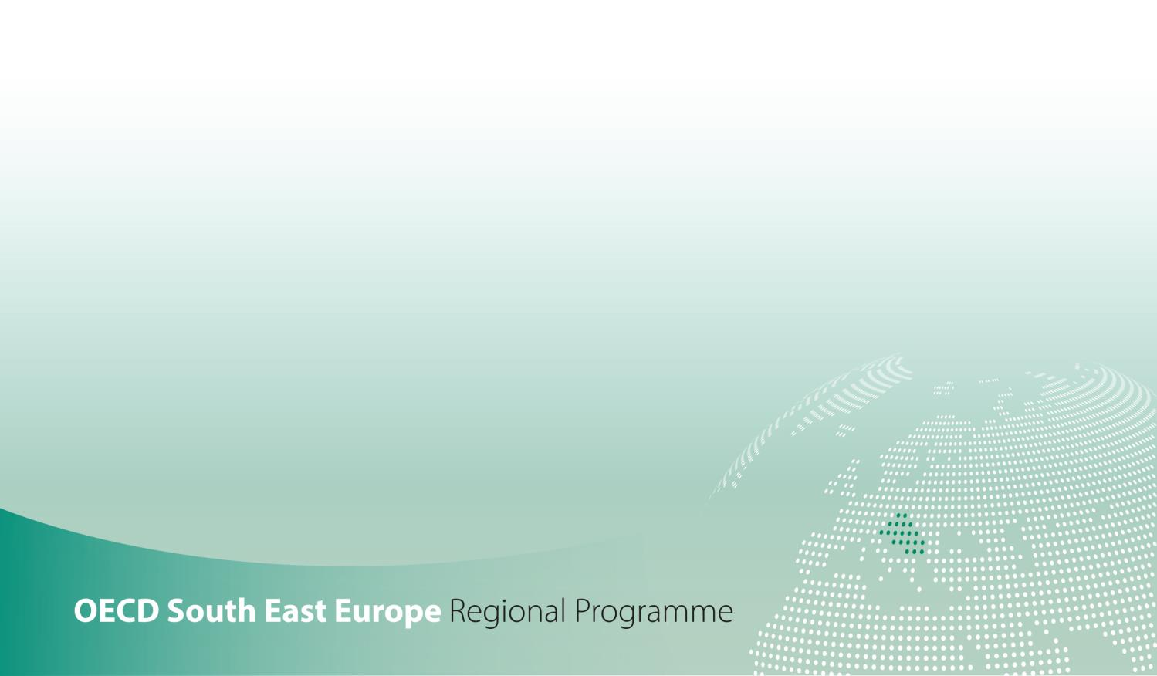

SME Policy Index
Western Balkans and Turkey 2022
ASSESSING THE IMPLEMENTATION OF THE SMALL BUSINESS ACT FOR EUROPE

DIMENSION 5a - Support services for SMEs
Qualitative indicators government questionnaire

Support services for SMEs assessment framework

Support services for SMEs dimension assesses the policies in the Western Balkans and Turkey that provide small and medium-sized enterprises (SMEs) with access to business support services (BSSs).
This dimension is structured around two sub-dimensions:
- Sub-dimension 1: Business support services provided by the government, assessing the BSS policy framework, the extent and types of services provided by public institutions, how information about them is disseminated, and how this provision is monitored and its effectiveness evaluated,
- Sub-dimension 2: Government initiatives to stimulate private BSSs, including the planning, implementation, monitoring and evaluation of policies to encourage the uptake of privately provided support services, particularly co-financing schemes.

Figure 1. Support services for SMEs assessment framework
Dimension 5a: Support services for SMEs
Outcome indicators
Provision of publicly (co-)funded business support services to SMEs
Percentage of SMEs benefitting from publicly (co-)funded business support services
Local availability of specialised training services
Sub-dimension 5a.1:  BSSs provided by the government |  |  | Sub-dimension 5a.2:  Government initiatives to stimulate private BSSs
Thematic block 1:  Planning and design | Thematic block 2:  Implementation | Thematic block 3:  Monitoring and evaluation | Thematic block 1:  Planning and design | Thematic block 2:  Implementation | Thematic block 3:  Monitoring and evaluation
Quantitative indicators
Amount of resources earmarked for co-funded BSS

Sub-dimension 1: BSSs provided by the government

Question |  |  | Response [expand box as necessary] | Source/evidence/links
Thematic block 1. Planning and design
 | Since the last assessment (January 2019) have there been any changes in the government SME strategy or equivalent document that provides a framework for the provision of business support services (BSSs)?
 | If yes | Please specify the changes that occurred
 | Are the strategy elements regarding business support services associated with:
 | a) | an action plan
 | b) | measurable targets
 | c) | timeframe
 | d) | expected impact
 | e) | corresponding budget
 | Is there a dedicated institution responsible for supporting the provision of BSSs?
 | If yes | Please specify the relevant institution and its allocated staff
 | Besides dedicated institution, are there other institutions (ministries, agencies, etc.) that provide BSSs?
 | If yes | Please provide more details on these institutions and the type of BSSs they provide
 | Since January 2019, has the government carried out new market research and analysis to assess:
 | a) | demand of business support services for SMEs?
 | b) | supply of business support services to SMEs?
 | Have any new BSS programmes been designed/ developed in co-operation with chambers of commerce or SME associations? If so, please specify/ provide one (few) examples.
 | Since January 2019, was any analysis of training needs of the SMEs conducted by the body in charge of BSSs provision? If yes, please specify
 | Are there background studies done on the entrepreneurial skills among SMEs?
 | If yes | Please specify the background studies on the entrepreneurial skills among SMEs conducted since January 2019
 |  | Do the business support services offered by the government reflect results of the study?
Thematic block 2. Implementation

 | Does the government provide business support programmes for SMEs?
 | If yes | Please provide more details on SMEs-specific business support programmes put in place by the government since January 2019
 | Has a budget been mobilised for business support programmes for SMEs?
 | If yes | Please indicate its total amount for 2020
 | Are any of the following types of BSSs being offered by the government?
 | a) | general information on business topics
 | b) | trainings
 | c) | mentoring and consulting
 | d) | physical infrastructure
 | Are there any tailored business support programmes for:
 | a) | start-ups? If yes, please specify
 | b) | female entrepreneurs? If yes, please specify
 | c) | young entrepreneurs? If yes, please specify
 | d) | specific industries/sectors? If yes, please specify
 | e) | SMEs at different stages of development? If yes, please specify
 | f) | the uptake of green practices? If yes, please specify
 | Is the government also providing business support services for SMEs via private sector service providers?
 | If yes | What are the eligibility criteria?
 |  | Are these services co-financed?
 |  | Does the co-financing take place through a voucher scheme or direct contribution?
 | Is there an online portal to inform SMEs on business support services provided by the government?
 | If yes | How often it is updated?
 |  | Does this portal combines information on all of the BSSs available from all government institutions at one place?
 | Are there any new programmes put in place since January 2019 to raise awareness and promote business support services?
 | If yes | Please specify
 | Thematic block 3. Monitoring and evaluation
 | Was there a change in the monitoring of the business support programmes provided by the government since the previous assessment (January 2019)?
 | If yes | Please specify what changes occurred since January 2019
 | Is there a publicly available annual report(s) on performance?
 | Is there an independent review of BSS delivery and its impacts?
 | If yes | Have any adjustments been made based on the results of these reports?
 | Is there any information regarding the impact of the programmes on SME performance in particular?
 | Are there formal mechanisms for SMEs to provide feedback on the available business support services programmes?
 | If yes | Please provide information on the mechanisms put in place since January 2019, if applicable
 |  | Please specify the type of feedback that is collected (e.g. feedback on specific sessions, on the use of grants, on satisfaction, effectiveness and quality of BSSs, etc.)
 |  | Have any adjustments been made based on the received feedback? If so, please specify
 | Is data being collected on how many SMEs participate in the different programmes?
 | If yes | Is there a database of indicators that is publically available online?
 | Is there any record of SMEs that benefited from BSSs provided by the government?
 | Are surveys used to collect information on SME usage and satisfaction with the business support programmes?
Questions related to the impact of the COVID-19 pandemic on BSSs provided by the government
 | Did the government put in place a specific responses to the pandemics with the respect to BSSs?
 | What lessons have been learnt in this area due to the pandemics and are there any strategic changes planned due to this experience?
Optional - Please provide any further information on BSSs provided by the government in your economy that you deem relevant for the assessment

How many entrepreneurs/SMEs received support services provided by the government in a year (latest data available)?
 | Type of BSS | Service provided (yes/no) | Number of entrepreneurs/ SMEs that benefited from the service
General information | Standards (certification, quality, export regulation)
 | Legislation
 | Business feasibility
 | Grants and export financial support
 | Financing opportunities
 | Labour regulation
 | Training opportunities
 | Market overview
 | Foreign markets
 | Trade fairs
 | Other
Trainings | Bookkeeping and accounting
 | Business plans
 | Financial planning and credit orientation
 | Leadership
 | ICT training
 | Resource efficiency
 | Presentation, sales and marketing
 | Other
Mentoring and consulting | Sales and marketing
 | Productions and ICT
 | HR management
 | Financial management
 | Strategic management
 | Other
Physical infrastructure | Incubators
 | Accelerators
 | Science parks
 | Other
TOTAL

Question | Response
Self-assessed level
(1 through 5, whole and half numbers)
Brief justification
Assessor name and institution

Sub-dimension 2: Government initiatives to stimulate private BSSs

Question |  |  | Response [expand box as necessary] | Evidence/links
Thematic block 1. Planning and design

 | Since the previous assessment (January 2019), have there been any changes of SME strategy documents or equivalent documents when it comes to stimulation of private business support services (BSSs)?
 | If yes | Please specify the strategy or the equivalent document that was revised as well as the changes that were introduced
 | Are the strategy elements regarding the stimulation of private business support services associated with:
 | a) | an action plan
 | b) | measurable targets
 | c) | timeframe
 | d) | expected impact
 | e) | corresponding budget
Thematic block 2. Implementation

 | Has a budget been mobilised for the implementation of the action plan?
 | If yes | Please indicate its total amount for 2020 (or the latest available information)
 |  | Was the total amount of budget used in 2019?
 | What actions of the strategy have been implemented by the government since January 2019?
 | How many of the actions have been implemented in line with the timeline?
 | How many of the targets from the strategy have been achieved? Please specify the targets that have been achieved
 | Does the government provide co-financing for business support services?
 | If yes | Have there been any changes since the last assessment (January 2019) in the co-financing for BSSs provided by the government? If so, please specify
 | If there is a co-financing mechanism, is it operational?
 | If yes | Please specify what type and percentage of co-financing is offered
 | Is there a formal structure to the co-financing mechanism?
 | If yes | Please specify
 | Are quality control mechanisms in place for co-financing initiatives (e.g. certificates, registration systems, reputational mechanisms)?
 | If yes | Please provide more information on quality control mechanisms in place
 | Are co-financing schemes conditional on the use of accredited consultants?
 | How many private providers of business support services operate in your economy?
 | What tools to stimulate private sector BSS are used by the government?
 | Does the government provide information to SMEs regarding the availability of private business support services (e.g. through website or B2B portal)?
 | If yes | Please specify
 | Is there an official data base of private sector experts, specialists and consultants which is easily accessible to public?
 | If yes | What are the requirements to be included in this data base?
Thematic block 3. Monitoring and evaluation

 | Are there any monitoring mechanisms in place for the implementation of the co-financing mechanism?
 | Is there independent evaluation of the co-financing mechanism?
 | If yes | How often?
 |  | Have any adjustments been made based on the results of these evaluations?
 | Are beneficiaries of co-financing made public?
 | Are surveys used to collect information on demand for and satisfaction with private business support services?
 | If yes | Please provide the results of the latest available survey
Questions related to the impact of the COVID-19 pandemic on private BSSs
 | Did the government put in place specific responses to the pandemics with the respect to BSSs?
 | Did the government provide any online BSSs or relevant information through a website/portal for SMEs affected by the COVID-19 crisis?
 | What lessons have been learnt in this area due to the pandemics and are there any strategic changes planned due to this experience?
Optional - Please provide any further information on government initiatives to stimulate private BSSs in your economy that you deem relevant for the assessment

Question | Response
Self-assessed level
(1 through 5, whole and half numbers)
Brief justification
Assessor name and institution

Business support services (BSS) are provided by public or private suppliers to SMEs and cover a wide range of non-financial services with the aim to increase their clients’ operating efficiency and to help them grow their business.
Services provided encompass a variety of subjects such as legal advice, consulting services, coaching and more depending on the needs and of the specificity of the needs of the clients.
This refers to government policies to increase SME access to privately provided business support services, through such measures as awareness-raising, co-financing and quality assurance mechanisms.
This refers to the existence of a quality assurance mechanism for companies receiving public funds through co-financing. Quality assurance can take many forms including company registration, certification, and quality assessment through client (SME) feedback.

