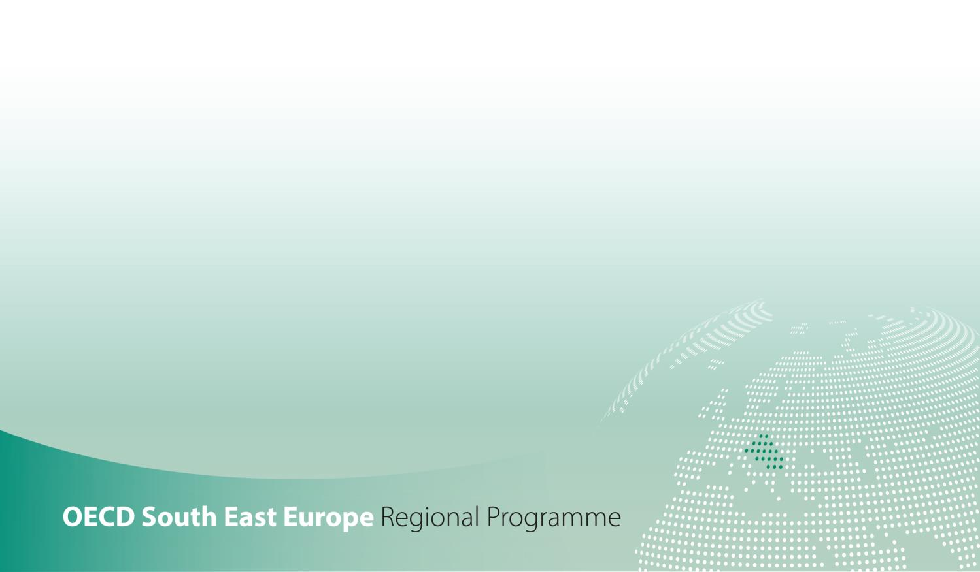

SME Policy Index
Western Balkans and Turkey 2022
ASSESSING THE IMPLEMENTATION OF THE SMALL BUSINESS ACT FOR EUROPE

DIMENSION 9 - SMEs in a green economy
Qualitative indicators government questionnaire

SMEs in a green economy assessment framework

SMEs in a green economy dimension assesses the provision of policies that promote green behaviour among small and medium-sized enterprises (SMEs) in the Western Balkans and Turkey.
This dimension is structured around two sub-dimensions:
- Sub-dimension 1: Framework for environmental policies targeting SMEs, which considers the greening aspects in national SME, sectoral and innovation policy frameworks,
- Sub-dimension 2: Incentives and instruments for SME greening, which looks at the various tools and instruments in place – such as regulatory and information-based instruments, financial incentives and green public procurement – to support SMEs in their greening efforts.
Figure 1. SMEs in a green economy assessment framework
Outcome indicators
Share of SMEs that adopted/use environmental management system (ISO 14001; local ones)
Share of SMEs with green certificates
Share of SMEs that have taken resource-efficiency measures
Share of SMEs with a turnover share more than 50% generated by green products or services
Share of SMEs that offer green products or services
Sub-dimension 9.1:  Framework for environmental policies targeting SMEs |  |  | Sub-dimension 9.2 :  Incentives and instruments for SME greening
Thematic block 1:  Planning and design | Thematic block 2:  Implementation | Thematic block 3:  Monitoring and evaluation | Thematic block 1:  Planning and design | Thematic block 2:  Implementation | Thematic block 3:  Monitoring and evaluation
Quantitative indicators:
Share of SMEs that have benefitted from public support measures for their green production methods
Share of SMEs that have benefitted from public support measures for their resource efficiency actions
Number of implemented environment-related actions that are specifically targeting SMEs

Sub-dimension 1: Framework for environmental policies targeting SMEs

Question |  |  | Response [expand box as necessary] | Source/evidence/links
Thematic block 1. Planning and design
1.1.1. | If any, please state which government strategies include environmental policies/measures for SMEs (e.g. as part of the SME development strategy or the environmental protection strategy).
 | In particular, does any of the government strategies containing environmental policies/measures for SMEs promote: | a) eco-efficient products, services and processes? | Yes [ ]  No [ ]
 |  | b) eco-innovation? | Yes [ ]  No [ ]
 |  | c) circular economy , more broadly – such as creation of innovative, circular economy-related business models (not just eco-innovation and eco-efficiency)? If so, please specify. | Yes [ ]  No [ ]
1.1.2. | Since the last assessment (January 2019) and specifically in the context of the new EC’s Green Deal, have there been any changes in environmental policies/measures/strategic documents that are specifically targeting SMEs? |  | Yes [ ]  No [ ]  n/a [ ]
 | If yes | Please specify: title, status (adopted, process of adoption, drafting, no activity), timeline, main objectives, measurable targets, expected impact, if these are sector specific and whether a corresponding budget exists.
1.1.3. | Is there a government body responsible for co-ordinating SME greening policies (e.g. body that is in charge for SME policy implementation or other)? |  | Yes [ ]  No [ ]
 | If yes | Please specify which government body/agency is responsible for greening policy for SMEs.
 |  | How is the co-ordination of the various authorities involved in planning and implementation of SME greening policies and measures ensured? Please elaborate.
1.1.4. | Was the private sector consulted in developing environmental policies for SMEs? If yes, please specify at what stages and through what means. |  | Yes [ ]  No [ ]
1.1.5. | In the context of SME greening, which private sector or local organisations is the government co-ordinating with and in what way?
1.1.6. | Which business associations (or other channels, such as research institutes, consultants) have been active in providing support to SMEs for greening?
1.1.7. | Do the private sector representatives (business associations, chambers of commerce, etc.) have their own SME greening policies? If yes, please elaborate which ones and provide more details on these policies. |  | Yes [ ]  No [ ]
Thematic block 2. Implementation

1.2.1. | Has a budget been mobilised for the action plan related to SME-specific environmental strategies/measures? |  | Yes [ ]  No [ ]
 | If yes | How much is the budget dedicated to environmental strategies/measures targeting SMEs?
1.2.2. | Which environmental policies/measures/strategic documents that are specifically targeting SMEs have been implemented?  Please share the relevant, most recent report on the implementation in the “Source/evidence/links” column.
1.2.3. | What targets of the abovementioned strategic documents have been achieved?
1.2.4. | Is there a specific allocation of funding for the promotion of SMEs going green? |  | Yes [ ]  No [ ]
 | If yes | Please specify the amount and its source (national budget, donor funds, other).
1.2.5. | Are there any operational sector-specific environmental policies targeting SMEs? |  | Yes [ ]  No [ ]
 | If yes | Please specify which ones and their status of implementation (on track, delayed due to the lack of fund/other reasons, other).
1.2.6. | Is the government body responsible for providing environmental guidance for SMEs fully operational? |  | Yes [ ]  No [ ]
 | If yes | How do you ensure the responsible body has the adequate capacity to perform its role (capacity building, trainings)? List key opportunities available for capacity building/training of the local government staff and whether and how often they have been taken in the last three years.
1.2.7. | Is the government co-ordinating with business associations and local councils for the delivery of environmental guidance to SMEs? |  | Yes [ ]  No [ ]
 | If yes | Please specify in what way, i.e. through which mechanisms? How successful have these mechanisms been so far? Please share the relevant reports.
Thematic block 3. Monitoring and evaluation

1.3.1. | Are environmental policies/measures targeted towards SMEs being regularly monitored? |  | Yes [ ]  No [ ]
1.3.2. | Is their evaluation conducted and if so, how is it carried out and at what frequency?
1.3.3. | Are the policies revised based on evaluation activities? If so, how?
1.3.4. | Are the stakeholders involved in feedback and evaluation and if yes, how?
1.3.5. | Has the impact assessment of the environmental policies targeted towards SMEs been undertaken? If so, by who and have any adjustments been made based on the received feedback?
1.3.6. | Have there been any analyses of costs and benefits of greening SMEs? If yes, please specify and share the report (if any) in the “Source/evidence/links” column. |  | Yes [ ]  No [ ]
1.3.7. | Does the government body in charge of providing environmental guidance monitor its effectiveness? If so, please specify how regularly this is done and share the latest report on this (if any).
Optional - Please provide any further information on the environmental policies targeting SMEs in your economy that you deem relevant for the assessment

Question | Response
Self-assessed level
(1 through 5, whole and half numbers)
Brief justification
Assessor name and institution

Sub-dimension 2: Incentives and instruments for SME greening

Question |  |  |  | Response [expand box as necessary] | Source/evidence/links
Thematic block 1. Planning and design
2.1.1. | Since the last assessment (January 2019), have there been any changes in the government provision of regulatory instruments for SME greening? |  |  | Yes [ ]  No [ ]
 | If yes | Please specify what regulatory instruments are used.
2.1.2. | Is the environmental permitting differentiated based on the level of environmental risk? |  |  | Yes [ ]  No [ ]
2.1.3. | Does the government provide financial incentives for the greening of SMEs? |  |  | Yes [ ]  No [ ]
 | If yes | Please specify what financial incentives are offered.
2.1.4. | Are SMEs subject to other types of incentive-based government instruments? (e.g. environmental taxes and charges, etc…) If so, please specify which ones.
2.1.5. | Are there green public procurement policies? |  |  | Yes [ ]  No [ ]
2.1.6. | Has the private sector been consulted in the development of:
 | a) | Regulatory instruments? If yes, please specify how, i.e. at what stages, through what means.
 | b) | Financial incentives? If yes, please specify how, i.e. at what stages, through what means.
 | c) | Green public procurement policies? If yes, please specify how, i.e. at what stages, through what means.
2.1.7. | Are the public support programmes to support SMEs in COVID-19 context tied to increased environmental performance, e.g. eligibility for grants, subsidies and soft loans conditioned on the higher environmental performance or the introduction of green business models? If yes, please specify. |  |  | Yes [ ]  No [ ]
Thematic block 2. Implementation

2.2.1. | Do national or local government authorities implement any programmes to raise SMEs' awareness and secure their initial engagement in green practices? If yes, please specify them. |  |  | Yes [ ]  No [ ]
2.2.2. | Is there evidence of SMEs benefiting from financial incentives for green practices? If so, please elaborate and provide any evidence in the “Source/evidence/links” column. |  |  | Yes [ ]  No [ ]
2.2.3. | Are sectoral approaches used in environmental permitting and compliance assurance activities? If yes, please specify. |  |  | Yes [ ]  No [ ]
2.2.4. | Do national or local government authorities promote the use of environmental management systems (EMS) among SMEs? |  |  | Yes [ ]  No [ ]
 | If yes |  | How many SMEs used EMS in the last calendar year?
2.2.5. | Do government authorities offer SMEs guidance on how to comply with environmental regulations and implement green practices? If yes, please specify. |  |  | Yes [ ]  No [ ]
2.2.6. | Do environmental authorities collaborate with business associations in developing sectoral green certification programmes? If yes, please specify how this collaboration is conducted and share more information on these programmes. |  |  | Yes [ ]  No [ ]
2.2.7. | Do environmental authorities collaborate with business associations to adapt EMS to SME needs? |  |  | Yes [ ]  No [ ]
 | If yes |  | Please specify what business associations are involved and in what way this collaboration is conducted.
2.2.8. | Are there "awards" or other forms of recognition of performance for green SMEs? If so, please specify them. |  |  | Yes [ ]  No [ ]
2.2.9. | Are there any funds involved into providing financial means that would facilitate SME transition to green economy? If so, which ones? Are they managed by the government? |  |  | Yes [ ]  No [ ]
Thematic block 3. Monitoring and evaluation

2.3.1. | Is there regular monitoring of regulatory instruments? If yes, please explain how this is done, what is the responsible body for this task and share the relevant reports if any. |  |  | Yes [ ]  No [ ]
2.3.2. | Is there regular monitoring of financial incentives? If yes, please explain how this is done, what is the responsible body for this task and share the relevant reports if any. |  |  | Yes [ ]  No [ ]
2.3.3. | Is there independent review of regulatory instruments and financial incentives? If yes, please explain who is in charge of this independent review. |  |  | Yes [ ]  No [ ]
2.3.4. | Does the government use any mechanism to receive feedback from SMEs on incentives? If so, please explain which one and provide more details on what type of incentives appear most effective. |  |  | Yes [ ]  No [ ]
2.3.5. | If there is evidence of SMEs benefiting from financial incentives for green practices, please specify. How many SMEs benefited from the incentives?
Optional - Please provide any further information on the Incentives and instruments for SME greening in your economy that you deem relevant for the assessment

Question | Response
Self-assessed level
(1 through 5, whole and half numbers)
Brief justification
Assessor name and institution

Self-assessed level (1 through 5, whole and half numbers) for the overall dimension - SMEs in a green economy:

Environmental policies could include SME-specific targets and/or national SME strategies could focus on environmental issues. For instance, these can refer to the promotion of eco-efficient processes and products or services, or to the activities geared towards promoting eco-innovation.
Eco-efficiency is based on the withstanding principles of the use of high efficiency production technology and methods, the use of less natural resources and energy for the same amount of production and the production of less waste. With this property, eco-efficiency does not just address environmental concerns, instead it also addresses “preservation of natural resources”, “industrial efficiency” and “economic development”.
Eco-innovation can be generally defined as innovation that results in a reduction of environmental impact, no matter whether or not that effect is intended.
Policies with the objective of increasing resource efficiency can create a variety of benefits – such as lower production costs, increased competitiveness, jobs, decreased dependency on commodity imports and fewer negative environmental impacts. A circular economy maximises the time products, materials and resources are of value in an economy and minimises waste generation. The basic concept of a circular economy depicts a production and consumption system that relies on the recycling, re-use, repair, remanufacturing, sharing of products, changing the consumption patterns and new business models and systems (EC, 2020). Policy mixes should address each of the main stages of the product lifecycle: material extraction, transport, production, consumption, recycling and final disposal.
Refers to the allocation of funds according to the approved budget.
SMEs going green comprise different activities the SMEs can undertake or go for: eco-efficient products, eco-innovation, more energy efficient or less material intensive production, etc.
Activities and measures are taking place, and are receiving funding.
Effectiveness of the environmental guidance refers to how effectively government bodies are reaching SMEs as well as if SMEs are receiving the appropriate guidance on how to adopt environmental practices.
Regulatory instruments include simplified permitting procedures and rules, inspections frequency for low-risk facilities, as well as technology standards (e.g. best-available technology, BAT or BATNEEC) and performance standards (limits on air emissions, water effluents or noise levels, requirements for material recycling and solid waste management regulations, energy efficiency or fuel economy standards, etc).
Financial incentives include tax incentives, loan guarantee schemes, reduced interest rates for loans used for environmental investments or grants.
Green public procurement policies refer to a direct supply chain pressure imposed by the government, i.e. using its purchasing power to choose environmentally friendly goods, services and works.
This involves replacing of customised permits with rules ("technical regulations") specific to a particular sector (e.g. manufacturing, agriculture, mining etc.) in the case of SMEs, for the purposes of regulatory simplification.
Environmental management systems include EMAS, ISO 14001 and local systems. Government may promote these through certain privileges in the permitting process or reduced inspection frequency.
These could include web-based guidance tools or industry magazines, newsletters, business or community events, workshops and training seminars.
Evaluation or review conducted by a separate agency/body/department than that responsible for implementation.

