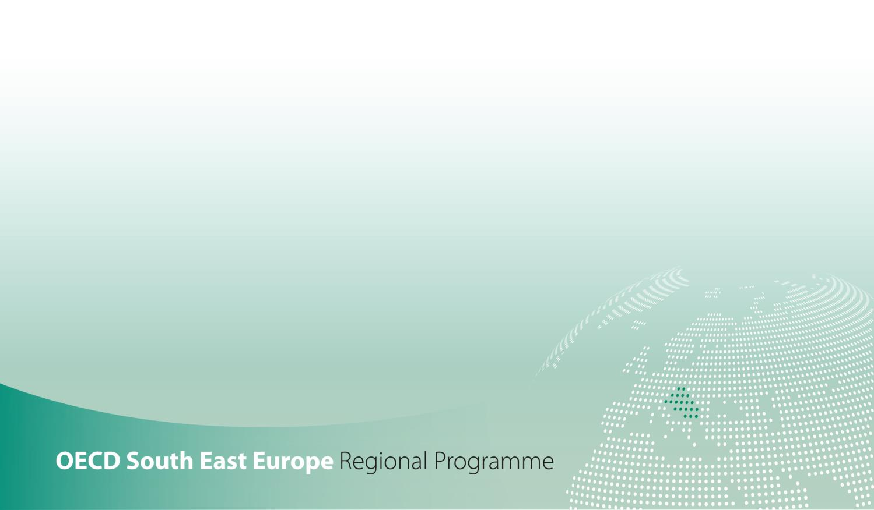

SME Policy Index
Western Balkans and Turkey 2022
ASSESSING THE IMPLEMENTATION OF THE SMALL BUSINESS ACT FOR EUROPE

DIMENSION 5a - Support services for SMEs
Qualitative indicators government questionnaire

Introduction
The SME Policy Index is a benchmarking tool for emerging economies, including the Western Balkans and Turkey (WBT), to monitor and evaluate progress in policies that support small and medium-sized enterprises (SMEs). The tool is structured around the ten principles of the Small Business Act for Europe (SBA), translated into 12 policy dimensions, which provide a wide-range of pro-enterprise measures to guide the design and implementation of SME policies.
The sixth, 2022 edition of the SME Policy Index for Western Balkans and Turkey aims to:

  - independently and rigorously assess SME policy settings and reforms against international best practice,
  - allow for comparison across time and participating WBT economies and measure convergence towards EU SME policy standard,
  - support governments in setting targets for SME policy developments and strategic priorities to further improve the business environment,
  - engage governments in policy dialogue and exchange of experiences, within the region and with OECD and EU member countries,
  - facilitate the prioritisation of government and donor activities in support of SME development,
  - assess and show progress in implementation of recommendations provided in the previous editions.

The new cycle of the SME Policy Index for Western Balkans and Turkey 2022 will be conducted in extraordinary circumstances caused by the COVID-19 pandemic. Its impact on local economies will also be taken into account in order to better inform policy-making in the region.

Assessment framework process and design
The SME Policy Index is based on the results of two parallel assessments government self-assessment, conducted by WBT economies’ governments and independent assessment, conducted by the OECD and its partner organisations and supported by the input collected from economy-based consultants with demonstrated expertise in relevant policy areas. The final scores are the result of a highly collaborative and consultative consolidation of these two assessments, enhanced by further desk research by the OECD and the partner organisations, as well as consultations with government representatives and with key stakeholders (e.g. private sector, business associations, academia & civil society) in the participating economies.
The questionnaire is structured around 12 policy dimensions each comprising up to 5 sub-dimensions that capture the critical elements of policy development. It proposes a scoring approach to transform qualitative information into numerical information and thus facilitating cross-economy comparison and allowing for systematic monitoring of policy developments. The questionnaire is intended to be used by government authorities and statistical agencies in charge of co-ordinating the SME Policy Index assessment process.

Guidance to fill out the qualitative assessment
The qualitative assessment is organised around thematic blocks each structured around a certain number of questions.
For each of these questions, please:
- Provide an answer, as fully as possible, citing all key sources in the foreseen grid,
- Assign a score, by using the scoring levels described in Table 1.

Description of score levels
Level 1 | Level 2 | Level 3 | Level 4 | Level 5
No framework (e.g. law, institution) exists to address the policy topic concerned | A draft or pilot framework exists, with some signs of government activity to address the policy area concerned | A solid framework, addressing the policy area concerned is in place and officially adopted | Level 3 plus evidence of a concrete record of effective policy implementation | Level 4 plus results of monitoring and evaluation inform policy framework design and implementation

- Match the highest performance score level characteristics that are fully described by your question responses and assign an according score of 1 to 5. If all requirements in one score level are met and at least half the requirements are met for the next score level, assign a half number score between the two levels.
- Provide a brief justification based on matching your question responses with the best corresponding level or half-level.
This questionnaire provides links to access the responses of the previous SME Policy Index 2019 questionnaire. If relevant for a given policy dimension, this questionnaire is complemented by a Statistic sheet. The assessment framework is accompanied by the Glossary of key terms – please refer systematically to it when answering the questionnaire.
Please complete and return this assessment by 15 September 2021 to the OECD.

Thank you for your time in completing this assessment. Your efforts are contributing towards removing barriers to SME development and unleashing their potential for driving inclusive economic growth in the Western Balkans and Turkey.
Should you have any questions regarding this assessment framework, please contact jovana.pavlovicdjukic@oecd.org and marijana.petrovic@oecd.org.

Assessor information
Mr. / Ms. | Name | Institution / Department | Title / Position | Email | Phone | Address

Questionnaire submission date: | 15/09/2021

Support services for SMEs assessment framework

Support services for SMEs dimension assesses the policies in the Western Balkans and Turkey that provide small and medium-sized enterprises (SMEs) with access to business support services (BSSs).
This dimension is structured around two sub-dimensions:
- Sub-dimension 1: Business support services provided by the government, assessing the BSS policy framework, the extent and types of services provided by public institutions, how information about them is disseminated, and how this provision is monitored and its effectiveness evaluated,
- Sub-dimension 2: Government initiatives to stimulate private BSSs, including the planning, implementation, monitoring and evaluation of policies to encourage the uptake of privately provided support services, particularly co-financing schemes.

Figure 1. Support services for SMEs assessment framework
Dimension 5a: Support services for SMEs
Outcome indicators
Provision of publicly (co-)funded business support services to SMEs
Percentage of SMEs benefitting from publicly (co-)funded business support services
Local availability of specialised training services
Sub-dimension 5a.1:  BSSs provided by the government |  |  | Sub-dimension 5a.2:  Government initiatives to stimulate private BSSs
Thematic block 1:  Planning and design | Thematic block 2:  Implementation | Thematic block 3:  Monitoring and evaluation | Thematic block 1:  Planning and design | Thematic block 2:  Implementation | Thematic block 3:  Monitoring and evaluation
Quantitative indicators
Amount of resources earmarked for co-funded BSS

Sub-dimension 1: BSSs provided by the government
[To access the responses of the previous SME Policy Index 2019 questionnaire click here (ctrl+left click)]

Question |  |  |  |  |  | Response [expand box as necessary] | Source/evidence/links
 | Thematic block 1. Planning and design
 | Since the last assessment (January 2019) have there been any changes in the government SME strategy or equivalent document that provides a framework for the provision of business support services (BSSs)? |  |  |  |  | Yes
 | If yes |  | Please specify the changes that occurred |  |  | Since the last assessment, the SME strategy plan has changed to KOSGEB (Turkish SME Development Organization) Strategy Plan, so some changes have been made in the strategy. | KOSGEB Strategy Plan  Target (H3.2) SME Guidance and Technical Consultancy System will be established and the supports to be provided within this scope will primarily encourage the institutionalization and branding of SMEs.  p.52  Target (H3.5): Contribution will be made to meet the priority needs of SMEs and to develop their capacities.  p.55  https://webdosya.kosgeb.gov.tr/Content/Upload/Dosya/Mevzuat/2020/KOSGEB_Stratejik_Plan%C4%B1_(2019-2023).pdf
 | Are the strategy elements regarding business support services associated with:
 | a) |  | an action plan |  |  | Yes  Also,  Development Agencies financial support and technical programs for SMEs are carried out within the framework of the 2014-2023 TR63 Regional Plan. | KOSGEB Strategy Plan  p. 52, 55  https://webdosya.kosgeb.gov.tr/Content/Upload/Dosya/Mevzuat/2020/KOSGEB_Stratejik_Plan%C4%B1_(2019-2023).pdf  https://www.dogaka.gov.tr/dokuman-merkezi/kurumsal-dokumanlar/tr63-bolge-plani-2014-2023
 | b) |  | measurable targets |  |  | Yes | KOSGEB Strategy Plan  p. 52, 55  https://webdosya.kosgeb.gov.tr/Content/Upload/Dosya/Mevzuat/2020/KOSGEB_Stratejik_Plan%C4%B1_(2019-2023).pdf
 | c) |  | timeframe |  |  | Yes | KOSGEB Strategy Plan  p. 52, 55  https://webdosya.kosgeb.gov.tr/Content/Upload/Dosya/Mevzuat/2020/KOSGEB_Stratejik_Plan%C4%B1_(2019-2023).pdf
 | d) |  | expected impact |  |  | Yes | KOSGEB Strategy Plan  p. 52, 55  https://webdosya.kosgeb.gov.tr/Content/Upload/Dosya/Mevzuat/2020/KOSGEB_Stratejik_Plan%C4%B1_(2019-2023).pdf
 | e) |  | corresponding budget |  |  | Yes | KOSGEB Strategy Plan  p. 52, 55  https://webdosya.kosgeb.gov.tr/Content/Upload/Dosya/Mevzuat/2020/KOSGEB_Stratejik_Plan%C4%B1_(2019-2023).pdf
 | Is there a dedicated institution responsible for supporting the provision of BSSs? |  |  |  |  | Yes, As stated in the strategy plan, KOSGEB has undertaken this task.
 | If yes |  | Please specify the relevant institution and its allocated staff |  |  | For H3.2  KOSGEB  Project Management Department  For H.3.5  KOSGEB  SME Development Department | https://webdosya.kosgeb.gov.tr/Content/Upload/Dosya/Mevzuat/2020/KOSGEB_Stratejik_Plan%C4%B1_(2019-2023).pdf
 | Besides dedicated institution, are there other institutions (ministries, agencies, etc.) that provide BSSs? |  |  |  |  | Yes, Chambers, Ministry of Trade (MoT), Ministry of Industry and Technology (MoIT), universities and other SME Business organizations.  Also, Investment support offices (YDOs) operates to build capacity and professionalism within the SMEs that operates in the city.  YDO conducts inventory studies on the following subjects:  ·Collecting data on the eligible sites for investment in an up-to-date manner from relevant institutions and organizations,  ·To compile data on investment costs, which are effective in taking investment decisions such as raw materials, energy, logistics, work force, investment place.  ·Keeping the information and records of the investors who benefited from the service of Investment Support Office through a database in an up-to-date manner.  ·To compile and update legislative information about investment permits and licensing transactions, under the guidance of Ministry.  · Providing, preparing, updating and reporting the other information and data required for informing the investor and enhancing the business and investment environment | Link for Ministry of Industry and Technology (MoIT) : https://www.sanayi.gov.tr/anasayfa  Within the framework of Ministry of Industry and Technology, there is Directorate General of Development Agencies that is responsible from 26 Development Agencies throughout Turkey and YDOs are part of Development Agencies.
 | If yes |  | Please provide more details on these institutions and the type of BSSs they provide |  |  | Financial Support Programs, Technical Support, Investment Support Services, Acting as a One Stop Shop for Promoting Investment Environment, Project Development Services, Regional Field Researches, Feasibility Reports, Action Plans, Strategies, Establishing Regional Cooperation Between Institutions.  Experts in PPKB organize meetings , workshops, apply surveys with private sector actors to make analysis and make them cooperate with eachother.  Program Management Offices (PYB) is another office which mostly lead the incentive procedures with the companies.  Ministry of Trade  Virtual Trade Academy  Chambers  Consulting and Training Services  Ministry of Industry and Technology,  The Scientific and Technological Research Council of Turkey (TUBITAK);  Regional Development Agencies (technical support mechanism),  Ministry of Trade, Ministry of Treasury and Finance  Consulting Services  Universities  Continuing Education Centres | Virtual Trade Academy  https://akademi.ticaret.gov.tr/cms/Index/?ReturnUrl=%2f  Universities  http://www.mtso.org.tr/tr/a/sanayi-ve-teknoloji-bakanligi-nin-ar-ge-teknoloji-ve-inovasyon-yonetimi-ve-bilgi-teknolojileri-yonetimi
 | Since January 2019, has the government carried out new market research and analysis to assess: |  |  |  |  | Yes
 | a) |  | demand of business support services for SMEs? |  |  | KOSGEB has made regular researches for the need of SMEs  https://www.sanayi.gov.tr/covid-19/rapor-yayin-ve-bilgilendirmeler#kosgeb-raporlari | Researches are carried out at determined intervals within the scope of KOSGEB's Information Management and Decision Support Department.  Information Management and Decision Support Department  ARTICLE 36 – (Amended: OG-6/7/2018-30470) (  1) The duties of the Information Management and Decision Support Department are listed below.  a) To establish and implement a system by determining the variables and analysis methods related to the evaluation of the current situation of SMEs and determining their needs,  b) To carry out cooperation studies with relevant institutions and organizations in order to provide the data needed for the work of the system to be established or KOSGEB units,  c) To prepare reports to direct KOSGEB support and activities,  ç) To provide support to the relevant units in the process of determining the method for the studies to be carried out by KOSGEB units,  d) To prepare reports and information notes on the effects of economic developments on SMEs,  e) To compile the results of the studies carried out by institutions and organizations for SMEs, to create an information pool,  f) To submit reports to the Senior Management on the development of policies and programs for SMEs and entrepreneurs,  g) To carry out joint studies with national and international institutions and organizations,  ğ) (Amended: OG-17/12/2020-31337) Coordinating the design process for support models,  h) To systematically monitor and evaluate the design, implementation and results of the supports and to carry out analysis studies,  ı) To prepare evaluation reports for supports,  i) Sharing the information created or produced by KOSGEB units, making suggestions that will constitute an input to the strategies and action plans of the Presidency in this regard,  j) (Annex: OG-17/12/2020-31337) (4) To carry out studies on legislative drafts, to express opinions, to prepare documents for implementation in order to ensure unity in practice in the works and transactions falling within the scope of duty of the Presidency and to produce solutions to the problems encountered,  k) To carry out the works related to the field of activity in line with other duties to be given by the Presidency, within the scope of the legislation.  KOSGEB ORGANIZATION REGULATION  p.7  Article 36  https://webdosya.kosgeb.gov.tr/Content/Upload/Dosya/Mevzuat/2020/Te%C5%9Fkilat_Y%C3%B6netmeli%C4%9Fi_(G%C3%BCncel).pdf
 | b) |  | supply of business support services to SMEs? |  |  | Researches are carried out at determined intervals within the scope of KOSGEB's Information Management and Decision Support Department.  https://www.sanayi.gov.tr/covid-19/rapor-yayin-ve-bilgilendirmeler#kosgeb-raporlari | Information Management and Decision Support Department  ARTICLE 36 – (Amended: OG-6/7/2018-30470) (  1) The duties of the Information Management and Decision Support Department are listed below.  a) To establish and implement a system by determining the variables and analysis methods related to the evaluation of the current situation of SMEs and determining their needs,  b) To carry out cooperation studies with relevant institutions and organizations in order to provide the data needed for the work of the system to be established or KOSGEB units,  c) To prepare reports to direct KOSGEB support and activities,  ç) To provide support to the relevant units in the process of determining the method for the studies to be carried out by KOSGEB units,  d) To prepare reports and information notes on the effects of economic developments on SMEs,  e) To compile the results of the studies carried out by institutions and organizations for SMEs, to create an information pool,  f) To submit reports to the Senior Management on the development of policies and programs for SMEs and entrepreneurs,  g) To carry out joint studies with national and international institutions and organizations,  ğ) (Amended: OG-17/12/2020-31337) Coordinating the design process for support models,  h) To systematically monitor and evaluate the design, implementation and results of the supports and to carry out analysis studies,  ı) To prepare evaluation reports for supports,  i) Sharing the information created or produced by KOSGEB units, making suggestions that will constitute an input to the strategies and action plans of the Presidency in this regard,  j) (Annex: OG-17/12/2020-31337) (4) To carry out studies on legislative drafts, to express opinions, to prepare documents for implementation in order to ensure unity in practice in the works and transactions falling within the scope of duty of the Presidency and to produce solutions to the problems encountered,  k) To carry out the works related to the field of activity in line with other duties to be given by the Presidency, within the scope of the legislation.  KOSGEB ORGANIZATION REGULATION  p.7  Article 36  https://webdosya.kosgeb.gov.tr/Content/Upload/Dosya/Mevzuat/2020/Te%C5%9Fkilat_Y%C3%B6netmeli%C4%9Fi_(G%C3%BCncel).pdf
 | Have any new BSS programs been designed/ developed in co-operation with chambers of commerce or SME associations? If so, please specify/ provide one (few) examples. |  |  |  |  | KOSGEB executive committee takes decisions for activities related to SME applications with meetings attended by chamber and federation representatives.  Also, Promoting Industrial Infrastructure Grant Programme and Strategical Structuring in SMEs Grant Programme were implemented in cooperation with chambers and SME Associations. Besides, Feasibility Support Programme was implemented..  Moreover, in 2019 Istanbul Chamber of Commerce initiated a new program called “First Step to Export” which aims to improve the export capacity of SMEs through technical mentor support. The program targets SMEs who have never made export or have not exceeded the amount of 100.000 $ in export.  And the following programs were carried out by a development agency (DOĞAKA):  - Greenhouse cultivation financial support program  - Furniture industry financial support program  - Tourism sector financial support program  - Tecnical support program for SMEs | Executive Committee Decision are not public available  https://ito.org.tr/tr/haberler/detay/ihracata-ilk-adim-ocakta-basliyor  https://kariyer.ticaret.edu.tr/projeler/ihracata-ilk-adim-projesi  https://www.dunya.com/kose-yazisi/ito-ihracata-ilk-adim-programi/457251  www.dogaka.gov.tr  https://www.gmka.gov.tr/kapanan-destek-programlari
 | Since January 2019, was any analysis of training needs of the SMEs conducted by the body in charge of BSSs provision? If yes, please specify |  |  |  |  | TNA regarding SMEs is regularly made by KOSGEB Information Management and Decision Support Department. In the light of these analysis, KOSGEB training portal is updated. | https://lms.kosgeb.gov.tr/
 | Are there background studies done on the entrepreneurial skills among SMEs? |  |  |  |  | Yes
 | If yes |  | Please specify the background studies on the entrepreneurial skills among SMEs conducted since January 2019 |  |  | KOSGEB Information Management and Decision Support Department’s workings also include the entrepreneurial skills  For local studies,  TR22 South Marmara Regional Innovation Strategy and Action Plan was launched in January, 2019.  Internal Entrepreneurship in Fast Growing SMEs: A Research in Ankara Province | https://www.gmka.gov.tr/dokumanlar/yayinlar/Bolgesel-Yenilik-Stratejisi-Ve-Eylem-Plani.pdf  https://www.researchgate.net/publication/342423030_Hizli_Buyuyen_KOBI_lerde_Ic_Girisimcilik_Ankara_Ilinde_Bir_Arastirma_Internal_Entrepreneurship_in_Fast_Growing_SME_s_A_Research_in_Ankara_Province
 |  |  | Do the business support services offered by the government reflect results of the study? |  |  | Yes
 | Thematic block 2. Implementation
 | Does the government provide business support programs for SMEs? |  |  |  |  | Yes
 | If yes |  | Please provide more details on SMEs-specific business support programs put in place by the government since January 2019 |  |  | Turkey Small and Medium Enterprises Development Organization (KOSGEB) has put into effect 2 support programs (İŞGEM/TEKMER Support Programme and The R&D, Product Development and Innovation Support Programme). Detailed information on these is given in other dimensions.  Note:  The R&D, Product Development and Innovation Support Program is the continuation of the R&D and Innovation Program that has been in effect since 2019.  Ministry of Trade  Virtual Trade Academy  Chambers  Consulting and Training Services  Ministry of Industry and Technology  Consulting Services  Universities  Continuing Education Center  Development Agencies provide technical support for SMEs generally designed through technical assistance assets like education, mentorship, consultancy and so on. These programs aim to develop the institutional and technical capacity of SMEs while increasing their competitiveness and innovation capacity. | https://www.kosgeb.gov.tr/site/tr/genel/destekdetay/7664/arge-urge-ve-inovasyon-destek-programi  https://www.kosgeb.gov.tr/site/tr/genel/destekdetay/6985/isgemtekmer-programi https://www.kosgeb.gov.tr/site/tr/genel/destekler/3/destekler https://ticaret.gov.tr/haberler/ticaret-bakanligindan-kobilere-e-ticarette-dayanisma-kampanyasi  Virtual Trade Academy  https://akademi.ticaret.gov.tr/cms/Index/?ReturnUrl=%2f  Universities  http://www.mtso.org.tr/tr/a/sanayi-ve-teknoloji-bakanligi-nin-ar-ge-teknoloji-ve-inovasyon-yonetimi-ve-bilgi-teknolojileri-yonetimi  Development Agencies  https://www.ankaraka.org.tr/tr/2021-yili-teknik-destek-programi_4951.html (Other agencies conduct similar programs as well, only an example is introduced here)
 | Has a budget been mobilised for business support programs for SMEs? |  |  |  |  | Yes
 | If yes |  | Please indicate its total amount for 2020 |  |  | KOSGEB Strategy Plan  p.52, p.55  The amount spent on Business Support Programs of KOSGEB for the first half of 2020 is 787.029.173  2020 Corporate Financial Situation and Expectations Report  p.3  https://webdosya.kosgeb.gov.tr/Content/Upload/Dosya/Mali%20Tablolar/Kurumsal%20Mali%20Durum%20ve%20Beklentiler%20Raporlar%C4%B1/2020_Y%C4%B1l%C4%B1_Kurumsal_Mali_Durum_ve_Beklentiler_Raporu.pdf | https://webdosya.kosgeb.gov.tr/Content/Upload/Dosya/Mevzuat/2020/KOSGEB_Stratejik_Plan%C4%B1_(2019-2023).pdf
 | Are any of the following types of BSSs being offered by the government? |  |  |  |  | Yes
 | a) |  | general information on business topics |  |  | Yes | https://www.kosgeb.gov.tr/site/tr/genel/iletisim  IPR Ambassadors  https://intellectual-property-helpdesk.ec.europa.eu/regional-helpdesks/european-ip-helpdesk/europe-ambassadors-team_en
 | b) |  | trainings |  |  | Yes | https://www.kosgeb.gov.tr/site/tr/genel/destekdetay/7664/arge-urge-ve-inovasyon-destek-programi  https://www.kosgeb.gov.tr/site/tr/genel/destekdetay/6985/isgemtekmer-programi  Virtual Trade Academy  https://akademi.ticaret.gov.tr/cms/Index/?ReturnUrl=%2f  EEN Trainings
 | c) |  | mentoring and consulting |  |  | The Small and Medium Enterprises Development Organization of Turkey (KOSGEB)-Advanced Entrepreneurship Program (The program is a financial support, however it includes such components like mentoring and consultancy.) | https://www.kosgeb.gov.tr/site/tr/genel/destekdetay/7664/arge-urge-ve-inovasyon-destek-programi  https://www.kosgeb.gov.tr/site/tr/genel/destekdetay/6985/isgemtekmer-programihttps://www.kosgeb.gov.tr/Content/Upload/Dosya/Girisimciligi%20Gelistirme%20Destek%20Programi/14-FRM.15.02.12_(00)_Mento%CC%88rlu%CC%88k_Dan%C4%B1s%CC%A7manl%C4%B1k_ve_I%CC%87s%CC%A7letme_Koc%CC%A7lug%CC%86u_Desteg%CC%86i_Bas%CC%A7vuru_Formu.pdf  EEN Consortia which have 50 partners consisting of universities, chambers, techno parks, KOSGEB, chambers and business support organizations are providing mentoring and coaching services in the context of import and export.  For example,  https://ebicege.org.tr/
 | d) |  | physical infrastructure |  |  | Yes | https://www.kosgeb.gov.tr/site/tr/genel/destekdetay/6985/isgemtekmer-programi  Techno parks, Technokents and Incubation centres are providing physical infrastructure for entrepreneurs, start-ups and SMEs.
 | Are there any tailored business support programs for:
 | a) |  | start-ups? If yes, please specify |  |  | KOSGEB TEKMER  Within the scope of the TEKMER Program, actors in the entrepreneurship ecosystem are supported to establish an incubation center. As you know, incubation centers serve both entrepreneurs with ideas and start-ups.  On the other hand, in R&D, Product Development and Innovation Support Programme, both entrepreneurs and start-ups and SMEs regardless of scale can receive support to realize their R&D, product development and innovation projects.  Istanbul Development Agency  “Entrepreneurship Financial Support Programme” (2021)  The program was developed with the fundamental aim to disseminate entrepreneurial culture and The R&D, Product Development improve the quality of the entrepreneurs in İstanbul through cooperative and Innovation Support Programme  sustainable support mechanisms which provide them with abundant opportunity to find direct access to finance, achieve faster growth, shift to the international market and so on. The main beneficiaries of this program are specify the support organizations, which provide fundamental services for start-ups. | https://www.kosgeb.gov.tr/site/tr/genel/destekdetay/6985/isgemtekmer-programi  https://www.kosgeb.gov.tr/site/tr/genel/destekdetay/7664/arge-urge-ve-inovasyon-destek-programi  Incubation Centres  https://www.startupnedir.com/turkiyedeki-kulucka-merkezleri/  https://www.istka.org.tr/media/132422/%C4%B0stka_2021_g%C4%B0r.pdf
 | b) |  | female entrepreneurs? If yes, please specify |  |  | The entrepreneurship program mentioned above concentrated on some thematic areas like social entrepreneurship, women entrepreneurship and so on as one of the main priorities. Under this and the previous entrepreneurship programs we have supported many projects to promote women entrepreneurship.  Also, Kişgem is a business development Centre for only female entrepreneurs  In KİŞGEMs, an environment of opportunity is created open to women who have a business idea, seek out ways and support to realize their business idea, and in short, want to build their future with their own hands.  General objectives in the establishment of KİŞGEMs;  - Supporting and helping small businesses in building and starting new businesses,  - Ensuring the establishment of successful businesses,  - To increase the growth and survival opportunities of businesses,  - Creating new job and employment opportunities,  - Directing local resources to new and/or different businesses,  - To encourage entrepreneurship,  - To provide a safe work environment,  - To provide a competitive environment,  - To accelerate regional and local development and to contribute to these issues,  - To support the local economy.  The target audience of the project;  - Women entrepreneurs who have a business idea and want to start their own business,  - Women entrepreneurs who have just established their businesses,  - Established businesses that have been operating for the last three years.  Supports to be provided to KİŞGEM Entrepreneurs;  - Preparation of an effective business plan,  - Management consultancy,  - Office and production area,  - Administrative services,  - Technical supports,  - Business network,  - Use of common office tools and equipment, legal and accounting advice when necessary.  It is seen as an important work within the scope of increasing the rate and within the framework of active employment measures of women entrepreneurs .  https://www.pendik.bel.tr/sayfa/detay/strateji-gelistirme-mudurlugu%7Ckisgem-projesi | https://en.kosgeb.gov.tr/site/tr/genel/destekdetay/7215/traditional-entrepreneur-support-programme  https://www.pendik.bel.tr/sayfa/detay/strateji-gelistirme-mudurlugu%7Ckisgem-projesi  http://www.gikamer.com/KİSGEM  https://www.akagim.com/
 | c) |  | young entrepreneurs? If yes, please specify |  |  | R&D, Product  The program mentioned above also concentrated on thematic areas like social entrepreneurship, young entrepreneurship as one of the main priorities. Under the previous entrepreneurship programs, we have supported many projects to promote young entrepreneurship.  The program is introduced with the aim to promote the entrepreneurial spirit and TEKMER Support Programme. culture among young people. The main beneficiaries of the program are universities, public bodies or civil society. Since the program does not directly target the students or the young people we can articulate it as a “business support program” for young entrepreneurs.  İstanbul Development Agency  “Supporting Entrepreneurship, Skills and Innovation Support Programme  Future of Children & Youth Program” 2021 | https://www.kosgeb.gov.tr/site/tr/genel/destekdetay/7664/arge-urge-ve-inovasyon-destek-programi  https://www.kosgeb.gov.tr/site/tr/genel/destekdetay/6985/isgemtekmer-programi  https://www.sogip.org/  https://www.istka.org.tr/media/132577/%C3%A7ocuklar-ve-gen%C3%A7ler-mali-destek-program%C4%B1-%C3%A7eg.pdf  ODTÜ Teknokent  Bigg  http://bigg.odtuteknokent.com.tr/
 | d) |  | specific industries/sectors? If yes, please specify |  |  | Calls are made within the scope of R&D, P&D and Innovation Support Program. These calls are planned with different support upper limits for small and medium-sized enterprises in selected sectors and subjects | https://www.kosgeb.gov.tr/site/tr/genel/destekdetay/7664/arge-urge-ve-inovasyon-destek-programi  Atom Ankara (Incubation Centre)  Animation Technology and Game Development Centre  http://atom.org.tr/#hakkimizda  Acıbadem University Incubation Centre (İstanbul)  Health Sector  https://www.acibademkulucka.com/
 | e) |  | SMEs at different stages of development? If yes, please specify |  |  | Calls are made within the scope of R&D, P&D and Innovation Support Program. These calls are planned with different support upper limits for small and medium-sized enterprises in selected sectors and subjects.  This program is developed with the fundamental aim to support Venture Capitals which will invest in technology and innovation centred starts-ups that have completed the early stages of growth and funding. As this program solely address venture capitals, start-ups can be evaluated as the indirect or ultimate beneficiaries and this support mechanism can be categorized as business support service.  İstanbul Development Agency  “Regional Entrepreneurship Fund” 2021 | https://www.kosgeb.gov.tr/site/tr/genel/destekdetay/7664/arge-urge-ve-inovasyon-destek-programi  https://www.istka.org.tr/duyurular/bolgesel-girisim-sermayesi-mali-destek-programi/  Inventist (İstanbul)  Pre-Incubation Centre  https://www.inventist.gen.tr/
 | f) |  | the uptake of green practices? If yes, please specify |  |  | All the Development Agencies conduct a wide range of activities in a common issue which is determined by The Ministry of Industry and Technology every year. The common issue of 2020/2021 was chosen as “Resource Efficiency” which aimed at eradicating the negative effects arising from the sustainable production, processing and consumption stages of natural resources.  Through this vision, Istanbul Development Agency carried out some work to promote environment-oriented and sustainable production process. For example, in our Entrepreneurship Result-Oriented Program” under the title of “Start-up-Investor Meetings” we have organized a demoday in “Energy Technology” where ecosystem stakeholders came together and made negotiations.  During this process under the same vision, Istanbul Development Agency organized different education and training programs especially targeting SMEs located in organized industrial sites under some categories like “energy efficiency in industry”, “government funds in energy efficiency” “applied clean production” and so on.  AHİKA adopted industrial symbiosis program in Aksaray Industrial Zone and gathered companies toghether to analyses if they benefit from their waste. | https://www.istka.org.tr/duyurular/temiz-uretim-programi/  Sera Kuluçka Merkezi (Kayseri)  Smart Living, Smart Urbanism, Renewable and Smart Energy Systems, Food Technologies  http://www.seraincubation.com/  https://www.istka.org.tr/tr/duyurular/enerji-teknolojileri-demo-gunu-icin-basvurular-acildi/  This link can be used rather than the other.
 | Is the government also providing business support services for SMEs via private sector service providers? |  |  |  |  | TEKMER Support Programme | https://www.kosgeb.gov.tr/site/tr/genel/destekdetay/6985/isgemtekmer-programi
 | If yes |  | What are the eligibility criteria? |  |  | The criteria in the second and third sections of the legislation document in the link on the side must be met.  İŞGEM criteria  ARTICLE 14 –  (1) The physical structure of İŞGEM must be independent and capable of performing the activities specified in the application. The physical structure to be allocated; management offices should consist of areas such as a common work area, workshops, event space, meeting room for entrepreneurs and businesses.  (2) The total area reserved for management offices, joint working area for entrepreneurs and businesses, meeting room, event area and machinery-equipment and software for common use should not be more than the total area of ​​the workshops.  (3) The physical structure of İŞGEM must have at least 20 workshops and a total indoor usage area of ​​at least 1,500 m2. This condition is not sought if fewer workshops and/or indoor usage areas are sufficient due to the establishment theme of İŞGEM and this is approved by the board.  (4) The physical structure of İŞGEM must be allocated or leased to İŞGEM free of charge for at least 5 years from the date of application. The terms of the lease must be such that they do not adversely affect the income-expenditure balance of İŞGEM.  (5) The enterprise to which a workshop will be allocated in İŞGEM must be established in İŞGEM or at most 1 year old as of the date of application to İŞGEM. This condition is not required for anchor companies.  (6) Workshop space allocated to anchor companies can be at most 30% of the total area of ​​the workshops.  (7) For businesses included in İŞGEM, the space allocation period cannot be longer than 5 years. There is no time limit for anchor companies.  (8) İŞGEM occupancy rate should be at least 50% at the end of the second year from the start of the program and should not fall below this rate as of the last day of the relevant period in subsequent follow-ups. The occupancy rate is calculated over the total workshop area.  (9) İŞGEM Executive Committee with at least three members is formed to take the strategic decisions of İŞGEM (entrepreneur/business acceptance/graduation, manager change, personnel selection or change etc.). In the İŞGEM Executive Committee, the manager of the relevant implementation unit is a natural member, and the other members are representatives of institutions/organizations who can apply as founders.  (10) The İŞGEM Executive Committee should meet at least twice a year, and meeting records should be kept.  (11) İŞGEM manager must be a graduate of at least four years of higher education and have at least five years of work experience in business management/consulting or in areas related to the theme/themes determined for İŞGEM.  (12) In order to ensure its financial sustainability, İŞGEM may generate income from rent and service fees received from its entrepreneurs/businesses, project income, income from venture partnerships with enterprises, local contributions, grants and similar sources. It cannot operate other than supporting services for entrepreneurs and businesses.  (13) The operating organization will not distribute the balance sheet profit during the support program; It should be included in the company/articles of association or in the General Assembly/Shareholders Board resolutions. However, if the physical structure of İŞGEM is allocated by KOSGEB, the balance sheet profit cannot be distributed as long as the right to use the İŞGEM name continues.  TEKMER Criteria  Article 15 –  (1) The physical structure of TEKMER must be independent and capable of performing the activities specified in the application. The physical structure to be allocated; management offices should consist of areas such as a common work area, workshops, event space, meeting room for entrepreneurs and businesses.  (2) The physical structure to be allocated for TEKMER must be allocated or leased to TEKMER free of charge for at least 5 years from the date of application. The conditions of the lease must be such that they do not adversely affect the income-expenditure balance of TEKMER.  (3) TEKMER's physical structure must have a closed area of ​​at least 1,000 m2. This condition is not sought if less indoor usage area is sufficient due to the establishment theme of TEKMER and this is approved by the board.  (4) The physical structure of TEKMER should not be within the boundaries of the Technology Development Zone established within the framework of the Technology Development Zone Law No. 4691. However, after the decision to support the application, the provision of this paragraph is not sought in case the physical structure is declared as a TDZ Zone or the regional boundaries change and TEKMER stays within the newly announced region boundaries.  (5) The workshop area allocated to anchor companies can be at most 30% of the total area of ​​the workshops.  (6) The entrepreneur/enterprise is allocated a place in TEKMER during the R&D or innovation business idea/project. There is no time limit for anchor companies.  (7) TEKMER's occupancy rate should be at least 50% at the end of the second year from the start of the program and should not fall below this rate as of the last day of the relevant period in subsequent follow-ups. The occupancy rate is calculated over the total workshop area.  (8) TEKMER Executive Committee with at least three members is formed to take the strategic decisions of TEKMER (entrepreneur/business acceptance/graduation, manager change, personnel selection or change etc.). In the TEKMER Executive Committee, the manager of the relevant application unit is a natural member, and the other members are representatives of institutions/organizations who can apply as founders.  (9) TEKMER Executive Committee should meet at least twice a year, meeting records should be kept.  (10) In order to ensure its financial sustainability, TEKMER may generate income from rent and service fees, project income, income from venture partnerships with enterprises, local contributions, grants and similar sources in order to ensure its financial sustainability. It cannot operate other than supporting services for entrepreneurs and businesses.  (11) Entrepreneurs/enterprises within the scope of R&D and innovation projects that are entitled to receive support from KOSGEB can also be allocated a place in TEKMER.  (12) A TEKMER manager must be a graduate of at least four years of higher education and have at least five years of work experience in business management/consulting or in areas related to the theme/themes determined for TEKMER.  (13) The operating organization will not distribute the balance sheet profit during the support program; It should be included in the company/articles of association or in the General Assembly/Shareholders Board resolutions.  Trainings especially on import, export or project management | İŞGEM TEKMER Support Program Implementation Principles  p.6-8  Article 14,15  https://webdosya.kosgeb.gov.tr/Content/Upload/Dosya/Girisimciligi%20Gelistirme%20Destek%20Programi/02.03.2020/isgem-tekmer/0_UE-21_(00)_I%CC%87S%CC%A7GEM_TEKMER_Destek_Program%C4%B1_Uygulama_Esaslar%C4%B1.pdf  https://een-istanbul.org/etkinlikler/proje-yonetimi-ve-standartlari-egitimi-1-1-1  http://www.aso2osb.org.tr/wp-content/uploads/2021/05/KOSGEB-Avrupa-%C4%B0%C5%9Fletmeler-Ag%C4%B1-E%C4%9Fitimleri.pdf
 |  |  | Are these services co-financed? |  |  | EEN is co-financed by EU Commission
 |  |  | Does the co-financing take place through a voucher scheme or direct contribution? |  |  | It is a direct contribution based on project approved.  In the relevant support program, a serious budget should be allocated for the establishment of the incubation center and the continuation of its activities. KOSGEB, on the other hand, provides support by applying a 75% support rate for the expenses specified in the legislation. For this reason, the remaining expenses and 25% of the supported expenses and the taxes belong to the structures that establish the incubation center. | https://www.kosgeb.gov.tr/site/tr/genel/destekdetay/6985/isgemtekmer-programi
 | Is there an online portal to inform SMEs on business support services provided by the government? |  |  |  |  | Yes | www.ahika.gov.tr and  https://www.yatirimadestek.gov.tr/
 | If yes |  |  |  | As soon as changes or announcements are made in the programs and  KOSGEB e-akademi being online platform of KOSGEB trainings is updated in every two months due to the necessity of SMEs. |  | www.kosgeb.gov.tr  https://lms.kosgeb.gov.tr/#
 |  |  |  |  | https://www.yatirimadestek.gov.tr/ is a portal combines many support in it.
 | Are there any new programs put in place since January 2019 to raise awareness and promote business support services? |  |  |  |  | Yes
 | If yes |  | Please specify |  |  | KOSGEB  Both KOSGEB presidency personnel and its directorates personnel located in 81 provinces carried out studies for the promotion of the 2 new support programs specified within the scope of Article 1.2.1. Videos, promotional documents, brochures and catalogues, social media contents etc. prepared by KOSGEB's corporate communication directorate were shared with the target audience.  Development Agency Programme  Technical Support Program for SMEs  Date of apply: 10.2020  End of apply: 12.2020  These support programmes of AHİKA Development Agency has been completed  This program covers SMEs both in tourism and manufacturing industry f ields.  Main purpose for tourism field: Promoting institutional and managerial support to the SMEs in tourism field within the scope of sustainability development to increase their productivity and managerial skills.  Main purpose for manufacturing industry field: Promoting institutional and managerial support to the SMEs to increase their productivity, managerial skills, resource, raw material and labor productivity skills.  - Financial support for Promoting Efficiency and institutionalization in Manufacturing Industry  Date of apply: 11.2019  For the tourism part, there are 38 applications submitted to AHİKA  For the manufacturing part, there are 23 applications submitted to AHİKA  Main purpose: the aim of this financial support is to increase competitiveness, institutionalization and sustainable innovative skills by increasing environmentalist awareness | https://www.ahika.gov.tr/assets/upload/dosyalar/td-2020-basvuru-rehberi.pdf  https://www.ahika.gov.tr/assets/upload/dosyalar/imalat-sanayiinde-verimlilik-ve-kurumsallasma-mdp-basvuru-rehberi.pdf
 |  | Thematic block 3. Monitoring and evaluation
 | Was there a change in the monitoring of the business support programs provided by the government since the previous assessment (January 2019)? |  |  |  |  | No
 | If yes |  | Please specify what changes occurred since January 2019
 | Is there a publicly available annual report(s) on performance? |  |  |  |  | Development Agencies prepare an impact assessment report after each program is closed.  Partially, targets of KOSGEB Strategic plan regarding BSS are available in KOSGEB activity report. | https://www.gmka.gov.tr/faaliyet-raporlari  https://www.istka.org.tr/projeler/tamamlanan-projeler/  H3.2 p.69- 70  H3.5 p.74  https://webdosya.kosgeb.gov.tr/Content/Upload/Dosya/Mali%20Tablolar/Faaliyet%20Raporlar%C4%B1/KOSGEB_2020_Y%C4%B1l%C4%B1_Faaliyet_Raporu.pdf
 | Is there an independent review of BSS delivery and its impacts? |  |  |  |  | Development Agencies prepare impact assessment reports after each program is closed.
 | If yes |  | Have any adjustments been made based on the results of these reports? |  |  | Not public available
 | Is there any information regarding the impact of the programs on SME performance in particular? |  |  |  |  | Yes | Not public available.  Researches and analyses are carried out at determined intervals within the scope of KOSGEB's Information Management and Decision Support Department.  Reports are not public available.  Information Management and Decision Support Department  ARTICLE 36 – (Amended: OG-6/7/2018-30470) (  1) The duties of the Information Management and Decision Support Department are listed below.  a) To establish and implement a system by determining the variables and analysis methods related to the evaluation of the current situation of SMEs and determining their needs,  b) To carry out cooperation studies with relevant institutions and organizations in order to provide the data needed for the work of the system to be established or KOSGEB units,  c) To prepare reports to direct KOSGEB support and activities,  ç) To provide support to the relevant units in the process of determining the method for the studies to be carried out by KOSGEB units,  d) To prepare reports and information notes on the effects of economic developments on SMEs,  e) To compile the results of the studies carried out by institutions and organizations for SMEs, to create an information pool,  f) To submit reports to the Senior Management on the development of policies and programs for SMEs and entrepreneurs,  g) To carry out joint studies with national and international institutions and organizations,  ğ) (Amended: OG-17/12/2020-31337) Coordinating the design process for support models,  h) To systematically monitor and evaluate the design, implementation and results of the supports and to carry out analysis studies,  ı) To prepare evaluation reports for supports,  i) Sharing the information created or produced by KOSGEB units, making suggestions that will constitute an input to the strategies and action plans of the Presidency in this regard,  j) (Annex: OG-17/12/2020-31337) (4) To carry out studies on legislative drafts, to express opinions, to prepare documents for implementation in order to ensure unity in practice in the works and transactions falling within the scope of duty of the Presidency and to produce solutions to the problems encountered,  k) To carry out the works related to the field of activity in line with other duties to be given by the Presidency, within the scope of the legislation.  KOSGEB ORGANIZATION REGULATION  p.7  Article 36  https://webdosya.kosgeb.gov.tr/Content/Upload/Dosya/Mevzuat/2020/Te%C5%9Fkilat_Y%C3%B6netmeli%C4%9Fi_(G%C3%BCncel).pdf
 | Are there formal mechanisms for SMEs to provide feedback on the available business support services programs? |  |  |  |  | Yes
 | If yes |  | Please provide information on the mechanisms put in place since January 2019, if applicable |  |  | While SMEs benefit from KOSGEB support programs, an SME expert from KOSGEB Directorates is assigned to them. They can provide all kinds of feedback to the relevant experts while carrying out their work and transactions related to their support. In addition, feedback is collected through official channels (sending petitions via e-government, official letters and e-mails).  Programs started in 2019 and after 2019 are still ongoing. (Between September 2019 and October 2021, many support programs were put into effect at KOSGEB.) So there is not an impact analysis ready. However, we have such a formal feedback and impact analysis after the program ended. We do surveys, interviews with the stakeholders and create a brief analyse and ending report.  Also, with the Training assessment forms that filled after each training by beneficiary, public organizations can gather information | https://lms.kosgeb.gov.tr/#
 |  |  | Please specify the type of feedback that is collected (e.g. feedback on specific sessions, on the use of grants, on satisfaction, effectiveness and quality of BSSs, etc.) |  |  | Survey and, interviews are done with the stakeholders and at the end, brief analyse and ending report is created.  Quality of service  Satisfaction  Service conditions | All support programs have monitoring periods and these periods are clarified by various monitoring forms.  https://www.sanayi.gov.tr/covid-19/rapor-yayin-ve-bilgilendirmeler#kosgeb-raporlari
 |  |  | Have any adjustments been made based on the received feedback? If so, please specify |  |  | Yes, the feedbacks that gathered from SMEs are used for improving trainings for all aspect.  As reports and analysis are finished, critics are made with related departments to improve the quality and effectiveness of our programs. | Changes are being made, but the reports are not publicly available. Revision dates of support programs are shown below.  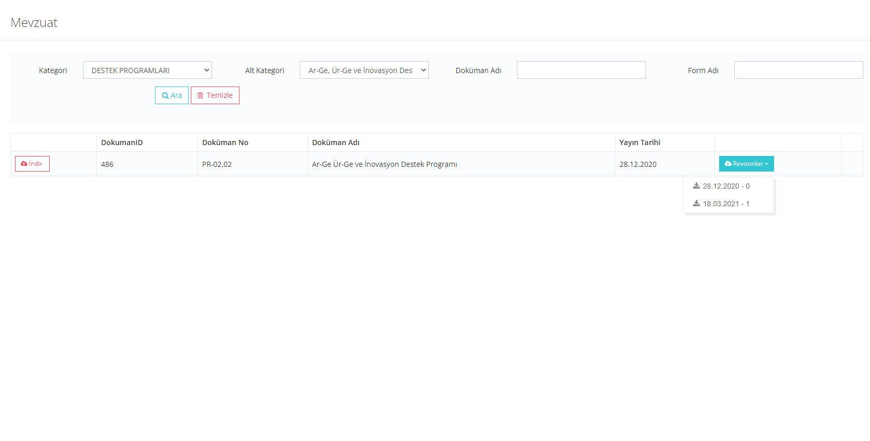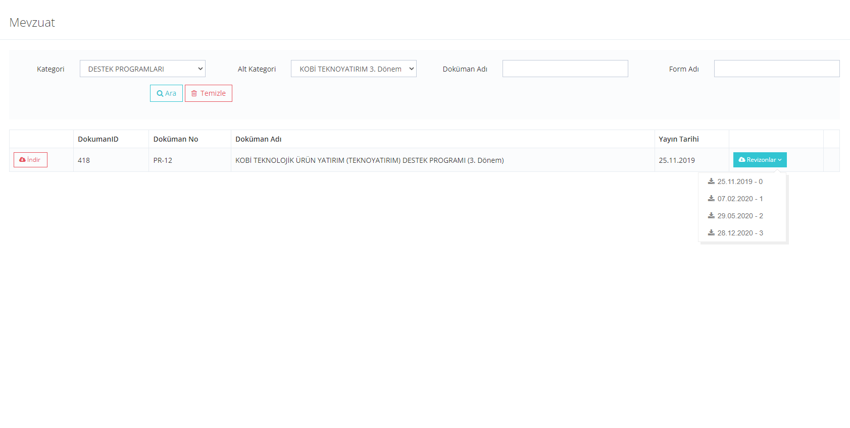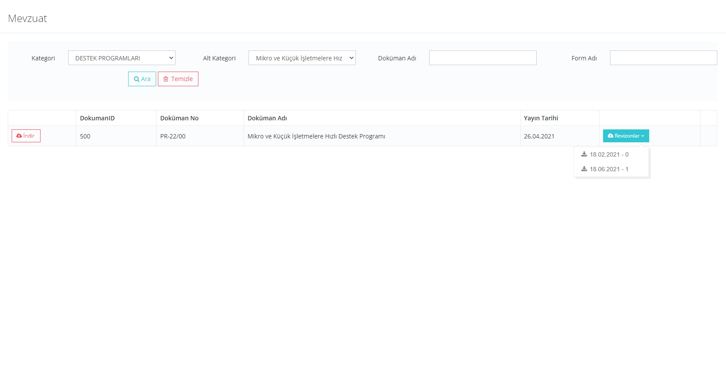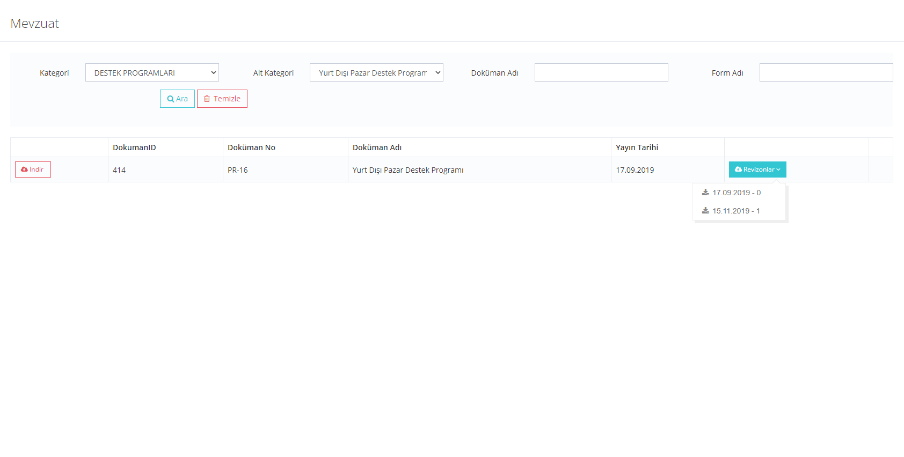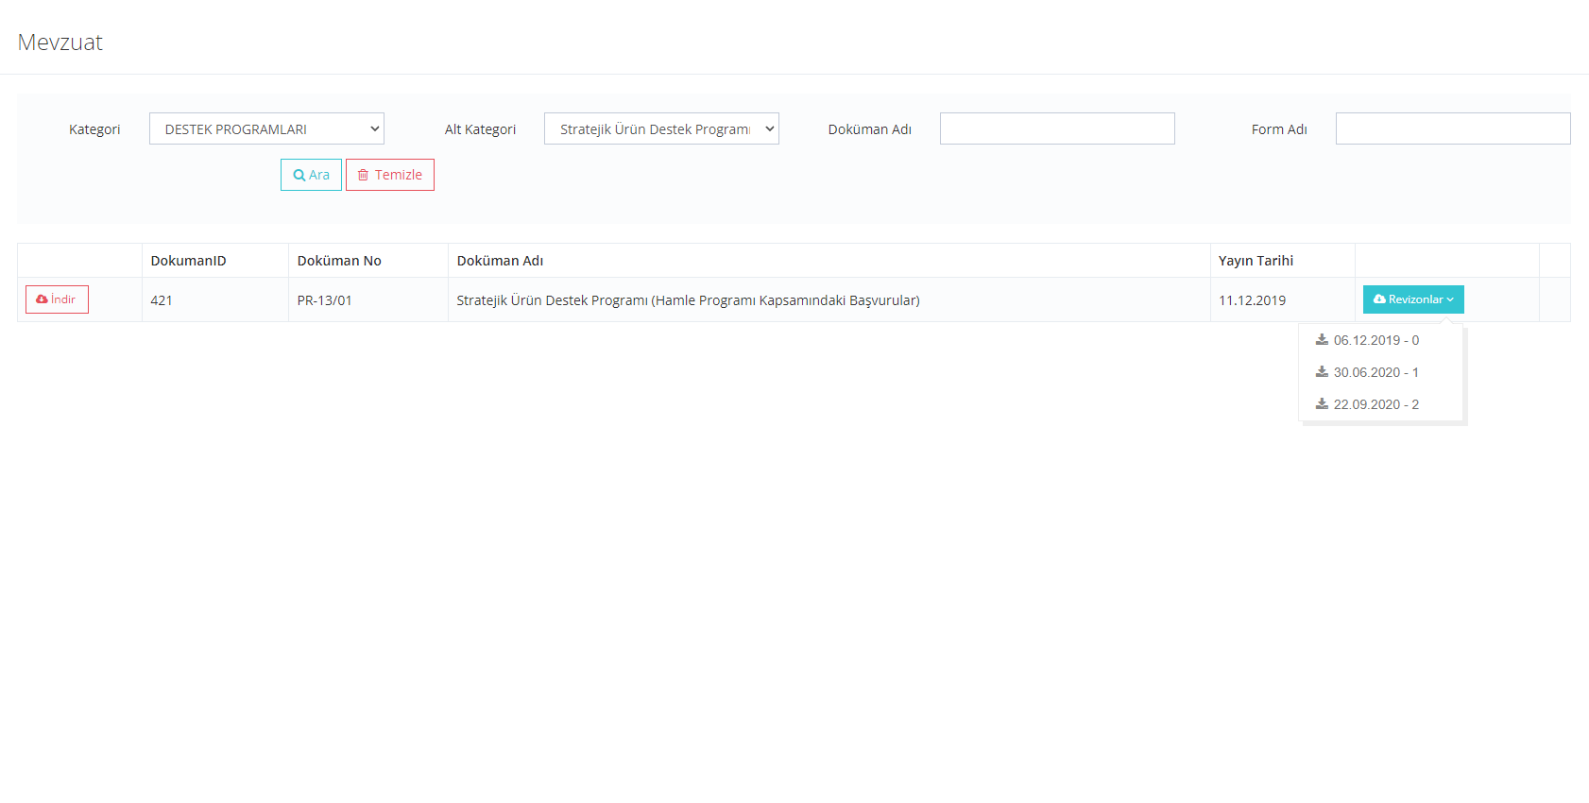
 | Is data being collected on how many SMEs participate in the different programs? |  |  |  |  | Yes, it depends the number of stakeholders’ achieve to get support and it is collected in e-akademi learning portal of KOSGEB | https://lms.kosgeb.gov.tr/
 |  | If yes |  | Is there a database of indicators that is publically available online? | annual report indicates the amount and number of projects implemented in supports.  All the project applications includes performance indicators which clarifies the actual progress of a projects towards the intended results it predicts. When a project is closed, the applicant offers the realized versions of these indicators through some reports so that the success of the project can be measured. As most of projects are carried out by support mechanisms which give direct support to SMEs and start-ups, these indicators usually display the number of the target groups who benefited from the concerned mechanisms (e.g number of start-ups who have received mentor support) When a grand program is totally closed, all the indicators of the projects are collected together to make an overall assessment. This database is coordinated by Monitoring and Evaluation Department of the Agency. |  | https://www.ahika.gov.tr/dokuman-merkezi  (the name of the file. “Faaliyet Raporu”).  Though such inner data can not be shared, the concerned database is used in preparing the impact assessment reports which are shared by public.  https://www.istka.org.tr/projeler/tamamlanan-projeler/
 | Is there any record of SMEs that benefited from BSSs provided by the government? |  |  |  |  | Yes, there is but it is not available for the public. There are general income and outcome (budget actualization) is available online.  This record is being kept by the beneficiaries of our entrepreneurship grand program. The incubators, accelerators or other entrepreneurship centers all have the records of the start-ups benefiting from these organizations; both for our projects and for the services they provide in general. | https://www.ahika.gov.tr/dokuman-merkezi  (The name of the file : “Mali gerçeklesmeler”)
 | Are surveys used to collect information on SME usage and satisfaction with the business support programs? |  |  |  |  | Yes
 | Questions related to the impact of the COVID-19 pandemic on BSSs provided by the government
 | Did the government put in a place a specific responses to the pandemics with the respect to BSSs? |  |  |  |  | A new support program was put into effect within the scope of the Rapid Support for Micro and Small Enterprises project, which was developed jointly with the World Bank and JICA.  In addition, if the enterprises benefiting from KOSGEB supports and affected by the pandemic declare that they cannot fulfil the activities or expenses in their projects, it is facilitated to extend their projects for 4 months.  In 2020, Fight Back Program Against Covid 19 was carried out.  Apart from the financial assistance ensured by the government, institutions like chambers of commerce; chambers of industry or professional associations gave some trainings and educations to raise awareness among SMEs in some major areas that has increasingly gained ground in pandemia like e-commerce, digitalisation, food safety and so on.  Taking into consideration of devastating effects of Covid-19 pandemic over micro and small enterprises (MSEs); a project (Rapid Support for Micro and Small Enterprises Project-MKI) has been designed by a loan from the World Bank and JICA aiming to relieve MSEs which are in prioritized strategic sectors. | https://www.kosgeb.gov.tr/site/tr/genel/destekdetay/7786/imalatci-mikro-ve-kucuk-isletmelere-hizli-destek-programi  https://istanbul.tarimorman.gov.tr/Haber/1394/Istanbul-Ticaret-Odasi-Ve-Guvenilir-Urun-Platformu-Isbirliginde-Duzenlenen-  https://www.istesob.org.tr/e-ticaret-egitimleri-basliyor/  https://webdosya.kosgeb.gov.tr/Content/Upload/Dosya/Hizli%20Destek%20Projesi/2021.06.19/Project_Summary__EN.pdf
 | What lessons have been learnt in this area due to the pandemics and are there any strategic changes planned due to this experience? |  |  |  |  | In COVID19 analysis created by the ministry with the assist of development agencies, there are specific indicators and variables which indicates how, why the pandemic affected the sectors. Also, the Ministry of Industry and Technology opened a program with the partnership of Japan Government and UNDP to analyse and educate SMEs in different areas in Turkey.  In terms of technical capacity; pandemics has revealed the necessity of increasing knowledge and experience among SMEs in being integrated to the process of digitalization through new assets like e-commerce, e-invoice, new marketing strategies and any kind of new methodology that has strategic importance for SMEs to gain a professional marketing identity and realize intended growth in this process. So BSSs has been canalized to new education and training programs particularly focusing on new tools and strategies to raise awareness and knowledge among SMES in the new era of technology and digitalization while making them stronger in coping up with the threats and opportunities of the pandemi process. | https://www.ahika.gov.tr/duyurular/ahika-2020-covid-19-ile-mucadele-ve-dayaniklilik-programi-ilan-edildi
Optional - Please provide any further information on BSSs provided by the government in your economy that you deem relevant for the assessment

How many entrepreneurs/SMEs received support services provided by the government in a year (latest data available)?

 | Type of BSS | Service provided (yes/no) | Number of entrepreneurs/ SMEs that benefited from the service
General information* | Standards (certification, quality, export regulation) | Yes | In 2020, within the scope of R&D and Innovation Support Programme was provided to 30 enterprises.7783*
 | Legislation | Yes
 | Business feasibility | Yes
 | Grants and export financial support | Yes
 | Financing opportunities | Yes
 | Labour regulation | Yes
 | Training opportunities | Yes | In 2020, within the scope of R&D and Innovation Support Programme was provided to 25 enterprises.
 | Market overview | Yes
 | Foreign markets | Yes
 | Trade fairs | Yes
 | Other | Yes
Trainings* | Bookkeeping and accounting | Yes | 3976*
 | Business plans | Yes
 | Financial planning and credit orientation | Yes
 | Leadership | Yes
 | ICT training | Yes
 | Resource efficiency | Yes
 | Presentation, sales and marketing | Yes
 | Other | Yes
Mentoring and consulting* | Sales and marketing | Yes | 2457*
 | Productions and ICT | Yes
 | HR management | Yes
 | Financial management | Yes
 | Strategic management | Yes
 | Other | Yes | 27
Physical infrastructure* | Incubators | Yes | In the scope of International Incubation Center and Accelerator Support Program was provided to 4 enterprises.374*
 | Accelerators | Yes
 | Science parks | Yes
 | Other | Yes | 27
TOTAL

*This data is provided in light of the data derived from the closing reports of the call for “Entrepreneurship Financial Support Program” 2021. As the program is not officially closed within the date of the survey, the given details can not be categorized. So the number shared for each title corresponds to the title on the whole independent of the subtitles.
Question | Response
Self-assessed level  (1 through 5, whole and half numbers) | 4,5
Brief justification | The studies carried out by KOSGEB for the needs of SMEs and the analyses and activities of NGOs on this issue show that the practices put into practice in our country on the subject of BSS are quite sufficient.
Assessor name and institution | N. Pınar Işın  Director of EU Coordination Unit  KOSGEB  Beyza Kuriş  SME Expert  EU Coordination Directorate  KOSGEB  Abdullah Aktepe  SME Expert  EU Coordination Directorate  KOSGEB

Sub-dimension 2: Government initiatives to stimulate private BSSs
[To access the responses of the previous SME Policy Index 2019 questionnaire click here (ctrl+left click)]

Question |  |  | Response [expand box as necessary] | Evidence/links
Thematic block 1. Planning and design

 | Since the previous assessment (January 2019), have there been any changes of SME strategy documents or equivalent documents when it comes to stimulation of private business support services (BSSs)? |  | Yes
 | If yes | Please specify the strategy or the equivalent document that was revised as well as the changes that were introduced | The Ministry of Industry and Technology Strategy Plan 2020- 2024  Target 2.5  In order to develop R&D activities in Technology Development Zones, measures will be taken to develop the ecosystem on issues such as infrastructure, competencies, cooperation, governance and financing.  Target 4.2  It will be ensured that the entrepreneurship ecosystem matures holistically in terms of talent capacity, cooperation mechanisms, participation capital, ease of entry, integration into the global ecosystem.  Target 4.3  With the Competitive Sectors Program, the business environment will be improved, research, development and innovation infrastructure will be strengthened and contribution will be made to the digital transformation of the industry.  Target 5.1  Developing cooperation between industrial enterprises, technology suppliers and other stakeholders in high technology areas; To this end, especially the number and efficiency of industry and technology zones will be increased.  KOSGEB Strategy Plan 2019- 2023  Target 1.4  Target and performance-oriented incubation and accelerator centres will be established.  Target 2.3  The knowledge and skills of entrepreneurs in establishing and running a business will be developed. | The Ministry of Industry and Technology Strategy Plan 2020- 2024  p.72-73, p.81-82, p.83-84, p.86-87  https://www.sanayi.gov.tr/plan-program-raporlar-ve-yayinlar/stratejik-planlar/mu2112012102  KOSGEB Strategy Plan 2019- 2023  p.45, p.49,  https://webdosya.kosgeb.gov.tr/Content/Upload/Dosya/Mevzuat/2020/KOSGEB_Stratejik_Plan%C4%B1_(2019-2023).pdf
 | Are the strategy elements regarding the stimulation of private business support services associated with: |  | Not applicable
 | a) | an action plan | Yes, details are stated in the strategy plans. | The Ministry of Industry and Technology Strategy Plan 2020- 2024  p.72-73, p.81-82, p.83-84, p.86-87  https://www.sanayi.gov.tr/plan-program-raporlar-ve-yayinlar/stratejik-planlar/mu2112012102  KOSGEB Strategy Plan 2019- 2023  p.45, p.49,  https://webdosya.kosgeb.gov.tr/Content/Upload/Dosya/Mevzuat/2020/KOSGEB_Stratejik_Plan%C4%B1_(2019-2023).pdf
 | b) | measurable targets | Yes, details are stated in the strategy plans. | The Ministry of Industry and Technology Strategy Plan 2020- 2024  p.72-73, p.81-82, p.83-84, p.86-87  https://www.sanayi.gov.tr/plan-program-raporlar-ve-yayinlar/stratejik-planlar/mu2112012102  KOSGEB Strategy Plan 2019- 2023  p.45, p.49,  https://webdosya.kosgeb.gov.tr/Content/Upload/Dosya/Mevzuat/2020/KOSGEB_Stratejik_Plan%C4%B1_(2019-2023).pdf
 | c) | timeframe | Yes, details are stated in the strategy plans. | The Ministry of Industry and Technology Strategy Plan 2020- 2024  p.72-73, p.81-82, p.83-84, p.86-87  https://www.sanayi.gov.tr/plan-program-raporlar-ve-yayinlar/stratejik-planlar/mu2112012102  KOSGEB Strategy Plan 2019- 2023  p.45, p.49,  https://webdosya.kosgeb.gov.tr/Content/Upload/Dosya/Mevzuat/2020/KOSGEB_Stratejik_Plan%C4%B1_(2019-2023).pdf
 | d) | expected impact | Yes, details are stated in the strategy plans. | The Ministry of Industry and Technology Strategy Plan 2020- 2024  p.72-73, p.81-82, p.83-84, p.86-87  https://www.sanayi.gov.tr/plan-program-raporlar-ve-yayinlar/stratejik-planlar/mu2112012102  KOSGEB Strategy Plan 2019- 2023  p.45, p.49,  https://webdosya.kosgeb.gov.tr/Content/Upload/Dosya/Mevzuat/2020/KOSGEB_Stratejik_Plan%C4%B1_(2019-2023).pdf
 | e) | corresponding budget | Yes, details are stated in the strategy plans. | The Ministry of Industry and Technology Strategy Plan 2020- 2024  p.72-73, p.81-82, p.83-84, p.86-87  https://www.sanayi.gov.tr/plan-program-raporlar-ve-yayinlar/stratejik-planlar/mu2112012102  KOSGEB Strategy Plan 2019- 2023  p.45, p.49,  https://webdosya.kosgeb.gov.tr/Content/Upload/Dosya/Mevzuat/2020/KOSGEB_Stratejik_Plan%C4%B1_(2019-2023).pdf
Thematic block 2. Implementation

 | Has a budget been mobilised for the implementation of the action plan?
 | If yes | Please indicate its total amount for 2020 (or the latest available information) | KOSGEB Strategy Plan 2019- 2023  Target 1.4  1.421.142,66 TRY for 2020  (Unfortunately, Turkey’s total amount is not applicable)  A Development Agency  Since some of the activities and project are in programs is a matter of public contract, the budget is not open for the public.  The DA has two action plans; one is for 1 year, the other one is 3 years general action plan. We prepare our 1-year plan due to 3-year general action plan. But all covers for both public and private sectors. | Target 1.4  p.96  https://webdosya.kosgeb.gov.tr/Content/Upload/Dosya/Mali%20Tablolar/Faaliyet%20Raporlar%C4%B1/KOSGEB_2020_Y%C4%B1l%C4%B1_Faaliyet_Raporu.pdf  Action plan for one year: https://www.ahika.gov.tr/dokuman-merkezi (with tha name of “Çalısma Programı”)  3 year plan is not open for public.
 |  | Was the total amount of budget used in 2019? | Because the budget is multi annual, total amount did not finish for KOSGEB.
 | What actions of the strategy have been implemented by the government since January 2019? |  | The Ministry of Industry and Technology Strategy Plan 2019- 2023  Target 2.5  Target 4.3  Target 5.1  KOSGEB Strategy Plan 2019- 2023  Target 1.4  Target 2.3 | The Ministry of Industry and Technology Strategy Plan 2019- 2023  Target 2.5 p.227-230  Target 4.3 p.254-255  Target 5.1 p.231  https://www.sanayi.gov.tr/plan-program-raporlar-ve-yayinlar/faaliyet-raporlari/mu2602011615  KOSGEB Strategy Plan 2019- 2023  Target 1.4  p.58-59  Target 2.3  p.64  https://webdosya.kosgeb.gov.tr/Content/Upload/Dosya/Mali%20Tablolar/Faaliyet%20Raporlar%C4%B1/KOSGEB_2020_Y%C4%B1l%C4%B1_Faaliyet_Raporu.pdf
 | How many of the actions have been implemented in line with the timeline? |  | The Ministry of Industry and Technology Strategy Plan 2019- 2023  Target 2.5  Target 4.3  Target 5.1  KOSGEB Strategy Plan 2019- 2023  Target 1.4  Target 2.3 | Ministry of Industry and Technology 2020 Annual Report  Target 2.5  p.227  The completion rate: 100%  Target 4.3  p.254  The completion rate: 95,78%  Target 5.1  p.231  The completion rate: 100%  https://www.sanayi.gov.tr/plan-program-raporlar-ve-yayinlar/faaliyet-raporlari/mu2602011615  KOSGEB 2020 Annual Report  Target 1.4  p.58  The completion rate of H1.4 is 67% by the end of 2020. The target is one hundred percent completion by 2023, but the target may be reached earlier than the expected date.  Target 2.3  p.64  The completion rate of H2.3 is a hundred percent..  https://webdosya.kosgeb.gov.tr/Content/Upload/Dosya/Mali%20Tablolar/Faaliyet%20Raporlar%C4%B1/KOSGEB_2020_Y%C4%B1l%C4%B1_Faaliyet_Raporu.pdf
 | How many of the targets from the strategy have been achieved? Please specify the targets that have been achieved |  | The Ministry of Industry and Technology Strategy Plan 2019- 2023  Target : 35 private companies 2.5  Reached: 27 Target 4.3  Target 5.1  KOSGEB Strategy Plan 2019- 2023  Target 1.4  Target 2.3  Development Agency (AHİKA)  Year: 2019  Program name: Promoting Efficiency and institutionalization in Manufacturing Industry  Program budget: 21.000.000,00 Turkish Lira | The Ministry of Industry and Technology Strategy Plan 2019- 2023  Target 2.5 p.227-230  Target 4.3 p.254-255  Target 5.1 p.231  https://www.sanayi.gov.tr/plan-program-raporlar-ve-yayinlar/faaliyet-raporlari/mu2602011615  KOSGEB Strategy Plan 2019- 2023  Target 1.4  p.58-59  Target 2.3  p.64  https://webdosya.kosgeb.gov.tr/Content/Upload/Dosya/Mali%20Tablolar/Faaliyet%20Raporlar%C4%B1/KOSGEB_2020_Y%C4%B1l%C4%B1_Faaliyet_Raporu.pdf  Development Agency  imalat-sanayiinde-verimlilik-ve-kurumsallasma-mdp-basvuru-rehberi.pdf (ahika.gov.tr)
 | Does the government provide co-financing for business support services? |  | Yes. Financial Support Programmes are implemented by the Regional Development Agencies through co-financing. | https://www.trakyaka.org.tr/tr/44109/2021-Yili-Teknik-Destek-Programlari-Ilani  https://izka.org.tr/2021-yili-teknik-destek-programi/  https://zafer.gov.tr/tr-tr/Faaliyetler/Proje-Destekleme/G%C3%BCncel-Destek-Programlar%C4%B1/2021-TD
 | If yes | Have there been any changes since the last assessment (January 2019) in the co-financing for BSSs provided by the government? If so, please specify | Maximum financial support rate was updated to 90% from 50% for SMEs in some specific support programmes  As the strategy plans have changed since the last assessment, co-financing topics for BSS is changed in the context.  The ıncubators, business environment and trainings are supported in regards of the purposes of the strategy plans. | The Ministry of Industry and Technology Strategy Plan 2019- 2023  Target 2.5 p.227-230  Target 4.3 p.254-255  Target 5.1 p.231  https://www.sanayi.gov.tr/plan-program-raporlar-ve-yayinlar/faaliyet-raporlari/mu2602011615  KOSGEB Strategy Plan 2019- 2023  Target 1.4  p.58-59  Target 2.3  p.64  https://webdosya.kosgeb.gov.tr/Content/Upload/Dosya/Mali%20Tablolar/Faaliyet%20Raporlar%C4%B1/KOSGEB_2020_Y%C4%B1l%C4%B1_Faaliyet_Raporu.pdf
 | If there is a co-financing mechanism, is it operational? |  | Yes
 | If yes | Please specify what type and percentage of co-financing is offered | It depends on the constitution or services that government decided to support. For example maximum financial support rate was updated to 90% from 50% for SMEs in some specific support programmes. In the private sector supports, there must be %50 co-financing. | https://www.kosgeb.gov.tr/site/tr/genel/destekdetay/6798/isletme-gelistirme-destek-programi  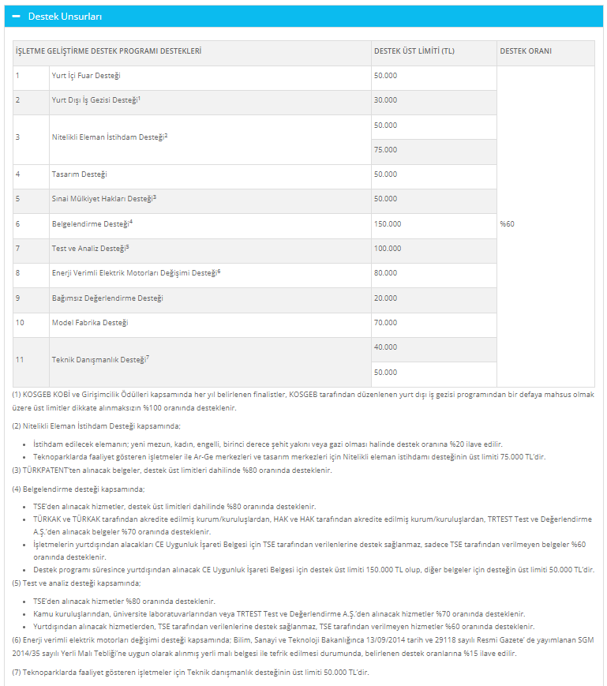
 | Is there a formal structure to the co-financing mechanism? |  | Yes
 | If yes | Please specify | Regulation of Development Agencies’ Support for Projects and Activities published in Official Gazette dated 08.11.2008 and numbered 27048. | https://www.resmigazete.gov.tr/eskiler/2008/11/20081108-3.htm
 | Are quality control mechanisms in place for co-financing initiatives (e.g. certificates, registration systems, reputational mechanisms)? |  | Yes
 | If yes | Please provide more information on quality control mechanisms in place | After a program is accepted by project department, Observation and Assessment Unit watches the project and standards until the project ends. | All monitoring processes are done online through the KOSGEB KDS system.  https://kds.kosgeb.gov.tr/UI/UILogin.aspx
 | Are co-financing schemes conditional on the use of accredited consultants? |  | No
 | How many private providers of business support services operate in your economy? |  | 87 Technology development Zones  5 İŞGEMs  Others are n/a
 | What tools to stimulate private sector BSS are used by the government? |  | - Technology Development Zones  - Entrepreneurship Ecosystems  - Competitive Sectors Programme  - Industry and Technology Zones  - Incubator Centres  - Start-up Skills | The Ministry of Industry and Technology Strategy Plan 2020- 2024  p.72-73, p.81-82, p.83-84, p.86-87  https://www.sanayi.gov.tr/plan-program-raporlar-ve-yayinlar/stratejik-planlar/mu2112012102  KOSGEB Strategy Plan 2019- 2023  p.45, p.49,  https://webdosya.kosgeb.gov.tr/Content/Upload/Dosya/Mevzuat/2020/KOSGEB_Stratejik_Plan%C4%B1_(2019-2023).pdf
 | Does the government provide information to SMEs regarding the availability of private business support services (e.g. through website or B2B portal)? |  | Yes, All information is provided by the constitutions separately. | www.yatirimadestek.gov.tr
 | If yes | Please specify | www.yatirimadestek.gov.tr is a platform where all governmental support information can be found.We prepare a guide for the detail of the program and anounce it on our web page.
 | Is there an official data base of private sector experts, specialists and consultants which is easily accessible to public? |  | Technical consultants that can be provided by KOSGEB, can be seen from KOSGEB Support System. | https://edevlet.kosgeb.gov.tr/EHizmetler?ReturnUrl=%2f
 | If yes | What are the requirements to be included in this data base? | Technical Advisor Authorization Application Control Table  1. PROFESSOR AND ASSOCIATIONS  1.1. Has/is working as a Professor or Associate Professor.  2. DOCTORAL GRADUATES  2.1. It meets the graduation requirement.  2.2. The duration of consultancy given to each business that is served is at least 20 (twenty) hours.  2.3. There is information on a total of 120 (one hundred and twenty) hours of consultancy service to at least 3 (three) different businesses in each field applied for.  2.4. There are documents that replace invoices/invoices belonging to the Consultancy Service showing that it provides a total of 120 (one hundred and twenty) hours of consultancy service to at least 3 (three) different businesses in each field it applies to.  3. MA GRADUATES  3.1. It meets the graduation requirement.  3.2. The duration of consultancy given to each business that is served is at least 20 (twenty) hours.  3.3. There is information on a total of 240 (two hundred and forty) hours of consultancy service to at least 3 (three) different businesses in each field applied for.  3.4. There are documents that replace invoices/invoices belonging to the Consultancy Service showing that it provides a total of 240 (two hundred and forty) hours of consultancy service to at least 3 (three) different businesses in each field it applies to.  4. MANAGERS OF LARGE or MEDIUM-SCALE BUSINESS  4.1. It meets the graduation requirement.  4.2. The business that serves as a middle or senior manager; appears to be a large or medium-sized enterprise.  4.3. It is seen that he has worked as a middle or senior manager for at least 5 (five) years in the last 10 (ten) years in large or medium-sized enterprises.  5. OWNERS/PARTNERS/EMPLOYERS OF BUSINESSES OPERATING IN THE CONSULTING SECTOR  5.1. It meets the graduation requirement.  5.2. It is seen that businesses operating in the consultancy sector have had at least 5 (five) years of owner/partner/employee in the last 10 (ten) years.  5.3. The duration of consultancy given to each business that is served is at least 20 (twenty) hours.  5.4. There is information on a total of 240 (two hundred and forty) hours of consultancy service to at least 3 (three) different businesses in each field applied for.  5.5. There are documents that replace invoices/invoices belonging to the Consultancy Service showing that it provides a total of 240 (two hundred and forty) hours of consultancy service to at least 3 (three) different businesses in each field it applies to.  6. INDIVIDUAL INVESTOR LICENSE  6.1. Within the scope of the Regulation on Individual Participation Capital published in the Official Gazette dated 15/2/2013 and numbered 28560, it has been declared that he is an experienced investor who has an Individual Participation Investor License as of the date of application and defined in the same Regulation. | https://edevlet.kosgeb.gov.tr/EHizmetler?ReturnUrl=%2f
Thematic block 3. Monitoring and evaluation

 | Are there any monitoring mechanisms in place for the implementation of the co-financing mechanism? |  | Yes, KOSGEB and Development Agencies (ex: AHİKA) has a unit which observes and control the projects in the implementation process. | KOSGEB and MoIT legally and regularly make assessments.  Researches are carried out within the scope of KOSGEB's Information Management and Decision Support Department.  Reports are not public available.  Information Management and Decision Support Department  ARTICLE 36 – (Amended: OG-6/7/2018-30470) (  1) The duties of the Information Management and Decision Support Department are listed below.  a) To establish and implement a system by determining the variables and analysis methods related to the evaluation of the current situation of SMEs and determining their needs,  b) To carry out cooperation studies with relevant institutions and organizations in order to provide the data needed for the work of the system to be established or KOSGEB units,  c) To prepare reports to direct KOSGEB support and activities,  ç) To provide support to the relevant units in the process of determining the method for the studies to be carried out by KOSGEB units,  d) To prepare reports and information notes on the effects of economic developments on SMEs,  e) To compile the results of the studies carried out by institutions and organizations for SMEs, to create an information pool,  f) To submit reports to the Senior Management on the development of policies and programs for SMEs and entrepreneurs,  g) To carry out joint studies with national and international institutions and organizations,  ğ) (Amended: OG-17/12/2020-31337) Coordinating the design process for support models,  h) To systematically monitor and evaluate the design, implementation and results of the supports and to carry out analysis studies,  ı) To prepare evaluation reports for supports,  i) Sharing the information created or produced by KOSGEB units, making suggestions that will constitute an input to the strategies and action plans of the Presidency in this regard,  j) (Annex: OG-17/12/2020-31337) (4) To carry out studies on legislative drafts, to express opinions, to prepare documents for implementation in order to ensure unity in practice in the works and transactions falling within the scope of duty of the Presidency and to produce solutions to the problems encountered,  k) To carry out the works related to the field of activity in line with other duties to be given by the Presidency, within the scope of the legislation.  KOSGEB ORGANIZATION REGULATION  p.7  Article 36  https://webdosya.kosgeb.gov.tr/Content/Upload/Dosya/Mevzuat/2020/Te%C5%9Fkilat_Y%C3%B6netmeli%C4%9Fi_(G%C3%BCncel).pdf  AHİKA Development Agency  Monitoring and Evaluation Unit (IDB)  The Monitoring and Evaluation Unit (IDB) works on the collection, analysis, notification and use of the necessary information for the purpose of monitoring and evaluating the plans and programs prepared by the Agency and the supported projects. It ensures that the efficiency, effectiveness, impact and sustainability of support activities are regularly followed up. For this reason, it is closely interested in the implementation and monitoring of the projects that are successful within the framework of the support programs, the control of their compliance with the laws and procedures, the problems and needs of the beneficiary.  https://www.ahika.gov.tr/kurumsal/organizasyon-yapisi/genel-sekreterlige-bagli-calisma-birimleri
 | Is there independent evaluation of the co-financing mechanism?
 | If yes | How often? | Once a year
 |  | Have any adjustments been made based on the results of these evaluations? | Yes, in the light of assessments, decisions about the incubators or what services were provided can be changed.
 | Are beneficiaries of co-financing made public? |  | Yes, Co-financing matter mentioned here in the survey is about sharing the total project budget with the stakeholder. The amount of co-financing is declared in programs on the guide. | https://www.ahika.gov.tr/assets/upload/dosyalar/ahika-sag-mdp-2020-rehber.pdf  https://www.ahika.gov.tr/assets/upload/dosyalar/ahika_covid_19_basvuru_rehberi.pdf  https://www.ahika.gov.tr/assets/upload/dosyalar/ahika-tag-mdp-2020-rehber.pdf  https://www.ahika.gov.tr/assets/upload/dosyalar/td-2020-basvuru-rehberi.pdf
 | Are surveys used to collect information on demand for and satisfaction with private business support services? |  | Yes
 | If yes | Please provide the results of the latest available survey | https://www.sanayi.gov.tr/covid-19/rapor-yayin-ve-bilgilendirmeler#kosgeb-raporlari
Questions related to the impact of the COVID-19 pandemic on private BSSs
 | Did the government put in place specific responses to the pandemics with the respect to BSSs? |  | Yes | Promoting Resilience and Fighting with Covid-19 Financial Support Program announced on the first quarter of 2020 throughout Turkey via Development Agencies.  Application Guide of Promoting Resilience and Fighting with Covid-19 Financial Support Program  p.4  https://www.ahika.gov.tr/assets/upload/dosyalar/ahika_covid_19_basvuru_rehberi.pdf  NAME OF THE PROGRAM  Promoting Resilience and Fighting with Covid-19 Financial Support Program  OVERALL OBJECTIVE OF THE PROGRAM  Supporting projects that contribute to the fight against the COVID-19 epidemic and offer urgent solutions to reduce the effects of the epidemic  PROGRAM PRIORITIES  Priority 1: Preventing and controlling the spread of the virus  Priority 2: Emergency preparedness and response studies for public health  Priority 3: Developing innovative practices to reduce the negative effects of the epidemic on the national and regional economy  TOTAL BUDGET OF THE PROGRAM  10.000.000 TL  MINIMUM AND MAXIMUM SUPPORT TO PROJECTS  Minimum Amount: 200.000 TL  Maximum Amount: 2,000,000 TL  For Non-Profit Institutions/Organizations, the support rate cannot be less than 25% and more than 100% of the total eligible cost of the project.  Support for For-profit Entities cannot be less than 25% and more than 80% of the total eligible cost of the project.  PROJECT DURATION  Minimum 1 month, maximum 3 months  SUITABLE APPLICANTS  - Public institutions  - Professional Organizations in Public Institutions, Unions, Chambers, Professional Organizations  - Organized Industrial Zones, Cooperatives  - Non-Governmental Organizations (Associations, Foundations, Unions, Trade Unions, Federations, Confederations)  - Universities  - Technology Development Zone Management Companies, Technology Transfer Office Companies, Municipal Companies  - For-profit Businesses
 | Did the government provide any online BSSs or relevant information through a website/portal for SMEs affected by the COVID-19 crisis? |  | Yes | SMEs are informed about up-to-date support and services through the investment support portal.  https://www.yatirimadestek.gov.tr/
 | What lessons have been learnt in this area due to the pandemics and are there any strategic changes planned due to this experience? |  | There is a analyse report which is prepared during the pandemic. The data was gathered by surveys and interviews with the public and private stakeholders. For a broad analysis:  TR71 Bölgesi Covid 19 Salgının Ekonomik ve Sosyal Etkilerinin Değerlendirilmesi.
Optional - Please provide any further information on government initiatives to stimulate private BSSs in your economy that you deem relevant for the assessment

Question | Response
Self-assessed level  (1 through 5, whole and half numbers) | 4,5
Brief justification | Our state institutions have given importance to the inclusion of the private sector in this regard, aiming to increase the support services provided especially to SMEs in many applications they have made in the field of BSS.
Assessor name and institution | N. Pınar Işın  Director of EU Coordination Unit  KOSGEB  Beyza Kuriş  SME Expert  EU Coordination Directorate  KOSGEB  Abdullah Aktepe  SME Expert  EU Coordination Directorate  KOSGEB

Self-assessed level (1 through 5, whole and half numbers) for the overall dimension – Support services for SMEs | Thanks to KOSGEB, which is the institution directly responsible for SMEs, as well as Development Agencies and other organizations, they are supported and served in many ways and methods on this subject. From this point of view, it can be said that our country has been quite successful in this regard.

Business support services (BSS) are provided by public or private suppliers to SMEs and cover a wide range of non-financial services with the aim to increase their clients’ operating efficiency and to help them grow their business.
Services provided encompass a variety of subjects such as legal advice, consulting services, coaching and more depending on the needs and of the specificity of the needs of the clients.
This refers to government policies to increase SME access to privately provided business support services, through such measures as awareness-raising, co-financing and quality assurance mechanisms.
This refers to the existence of a quality assurance mechanism for companies receiving public funds through co-financing. Quality assurance can take many forms including company registration, certification, and quality assessment through client (SME) feedback.

